Whole Home System
Product Details
The UltraSafe System filters use a proprietary patented electro-positive filter media that rapidly adsorbs particles, as small as a few nanometers.
  - Advanced Ultra Filtration
  - Great tasting water
  - NSF certified, 42, 53, 61, 372
  - No Chemicals
  - Large capacity filters
  - Annual change out in most applications
  - Water softening (Optional on request)
  - Low cost to maintain
  - Easy to maintain

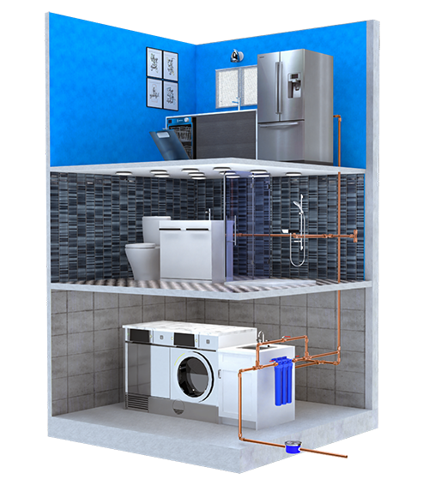
Package Includes:
Whole Home Unit – (1)
UnderSink Units – (2)
Shower Unit – (1)
LivingWater Unit – (1)

Have more?
…Add them to the order.

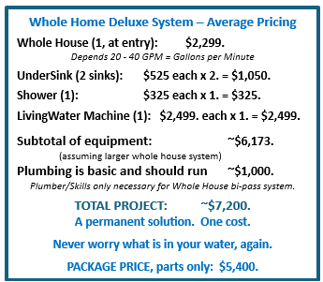
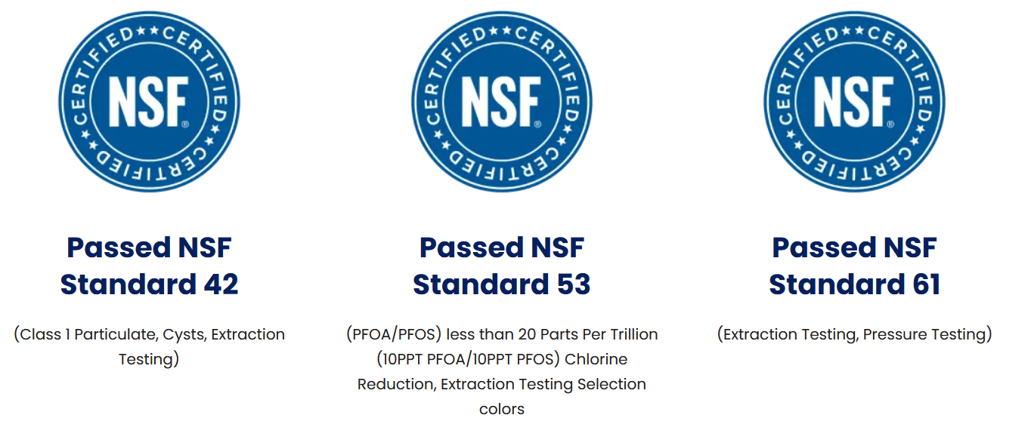
SKU T-WH2040LW-01 Shop | Ultra Home
UltraSafe System – Well Water System
UltraSafe System™
Filtration System for Under 20 - 40 GPM

Quality Water For Your Whole House.
The UltraHome Filtration System is your clean water solution for you & your family. It creates healthy water for drinking, cleaning, and bathing. Our filtration system uses the same technology used by NASA. It filters water with no chemicals. The UltraHome Filtration System creates healthy and great tasting water for your family to enjoy.

Purer Then Bottle Water

Saving the planet, replacing bottled water with UltraHome Filtration System.
- No Chemicals.
- 99.999999% Removal of Bacteria
- >99.99% Removal of Spores, Bacteria, Cysts
- PFAS / PFOS / PFOA – Forever Chemicals
- Viruses, pathogens, mold, fungus
- ‘Allowable Toxins’ – chlorine
- Heavy Metals, Lead, Micro-Plastics
- Pesticides, Pharmaceuticals
- Adding Micro-Nutrients & Minerals for Optimum Health benefits
- Eco-Friendly
- Eliminates the use for plastic water bottles

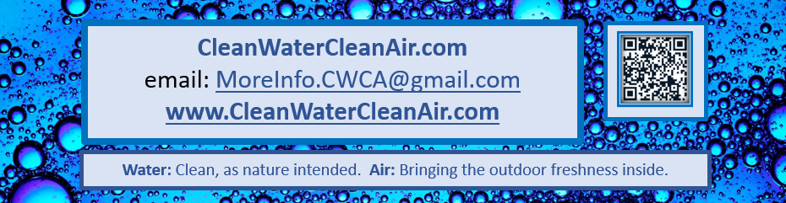

Unit Price: $5,400.
Drop-Down Select ‘GPM’ = Price
Tax (Varies) $
Shipping (Varies) $
Total $
Never question what is in your water again.

