The Science
CleanAir
Science

CleanWater
Science
Hyperlink to below - Air

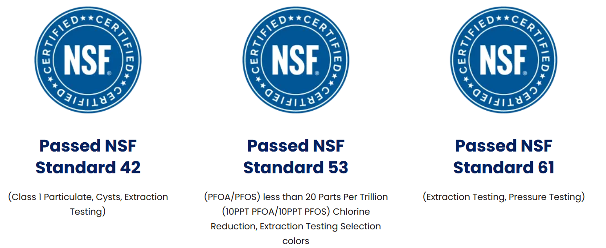
Water Science

-General Water Science Hyperlink to below
-LivingWater: The Champagne of Water Hyperlink to below
-Toppen Water Science Hyperlink to below

General Water Science
Simple Math (Hyperlink to PDF, in SciWater Folder)
Hydrogen As a Therapeutic Anti-Oxidant: (PDF, in SciWater Folder)
Hydrogenized Water: (PDF, in SciWater Folder)
The GastroIntestinal System, by Infinity2, Inc. Form #1606: (PDF – Nothing WithoutWater.PDF)
Molecular Hydrogen Therapy: A Review of Studies (PDF, in SciWater Folder)
Bottled Water Comparison Charts: (PDF, in SciWater Folder - TBD)

LivingWater: The Champagne of Water
Dialing to your pH:
2.5 pH sanitizes. It is like bleach with no chemicals.
4.0 – 5.5 pH is excellent for external skin for humans and pets.
7.0 pH – Pets, kids under 5 years old and when taking pharmaceuticals.
8.5 – 10.0 pH is GREAT for human consumption and ENERGY.
11.5 pH works as a degreaser.

TAKE
The Water Challenge
LEARN
LivingWater Uses
Hyperlink, open PDF –
in new window for each…

LivingWater Science:
Not All Water is Created Equal: Hyperlink
https://vollara.blob.core.windows.net/resources-prod/Water/Important%20Documents/LWFeaturesBenefits.pdf

Effects of DDI Technology: Hyperlink
https://vollara.blob.core.windows.net/resources-prod/Water/Important%20Documents/EffectsofDDITechnology.pdf

pH Chlorine Charts: Hyperlink
https://vollara.blob.core.windows.net/resources-prod/Water/Important%20Documents/PH_ChlorineChart.pdf

Living Water Uses: Hyperlink
https://vollara.blob.core.windows.net/resources-prod/Water/Important%20Documents/livingwater_usage_sheet.pdf

Toppen Water Science: One piece at a time or all at once. Try our Mosaic Shower Filter or Ultra UnderSink filter. You can feel the difference and smell only the good things. No chlorine, no wet dog smell. Just fresh, CleanWater.

NSF-ANSI – Testing

NSF / ANSI 42 Hyperlink to Toppen Test- Filters are certified to reduce aesthetic impurities such as chlorine and taste/odor: Point-of-use (under the sink, water pitcher, etc.) or point-of-entry (whole house) treatment systems.

NSF / ANSI 53 Hyperlink to Toppen Test - Filters are certified to reduce a contaminant with a health effect. Health effects are set in this standard as regulated by the U.S. Environmental Protection Agency (EPA) and Health Canada. Both standards 42 and 53 cover adsorption/filtration which occurs when liquid, gas or dissolved/suspended matter adheres to the surface of, or in the pores of, an adsorbent media. Carbon filters are an example of this type of product.

NSF / ANSI 61 Hyperlink to Toppen Test – Materials used to manufacture cause no toxicity.

NSF / ANSI 372 Hyperlink to Toppen Test – Lead Free.

Hyperlink each bold-text above to the actual text, PDF’d test; under Toppen Science. Two for Lead (372).

EPA-PFAS-Explained (PDF, open in new window? PDF in Graphics folder, PDF-Folder)

Link to NSF.org: https://www.nsf.org/consumer-resources/articles/standards-water-treatment-systems)
(open in new window?)
Water Science – TOTAL HOME SOLUTION (hyperlink to PDF – WholeHouseSample.pdf, PDF in Graphics folder, PDF-Folder)
Water Science – INDUSTRIAL SYSTEM SOLUTION (hyperlink to PDF – IndustrialSystems.pdf; PDF in Graphics folder, PDF-Folder)
Water Science – DATA CENTER SOLUTION (hyperlink to PDF – IndustrialSystems.pdf)
How Does It Work? (hyperlink to PDF – HowDoesItWork.pdf; PDF in Graphics folder, PDF-Folder)
Simple Math, Science and Wellness (hyperlink to PDF – SimpleMath.pdf)
Toppen Science Cheat Sheet (hyperlink to PDF – Toppen-WaterSystemExplanation.pdf; PDF in Graphics folder, PDF-Folder)

Graphic A,B & C below if above does not cooperate. Otherwise delete these to prevent repeat.

(Graphic A - below)
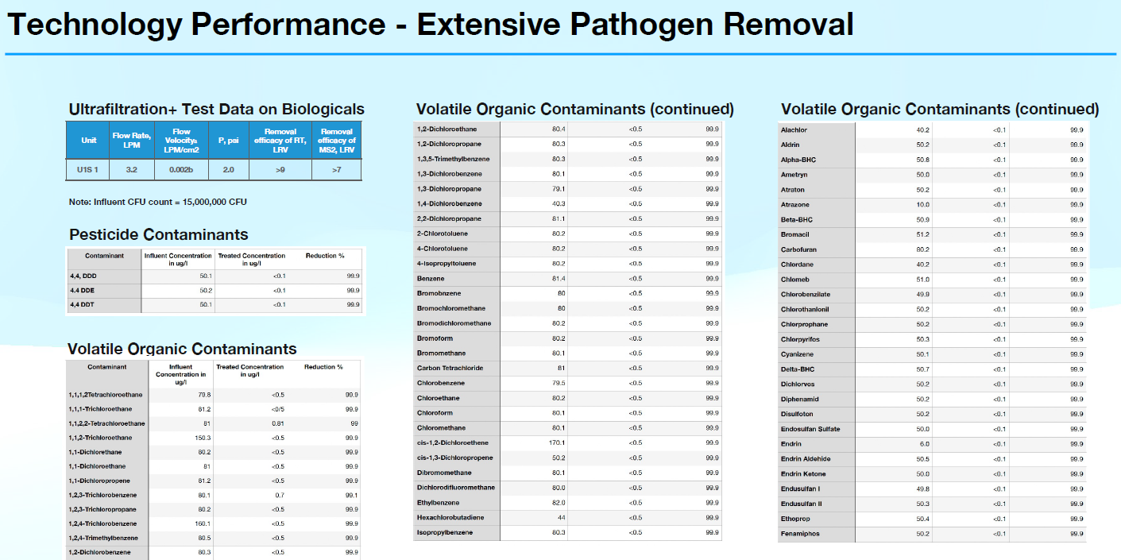

(Graphic B)

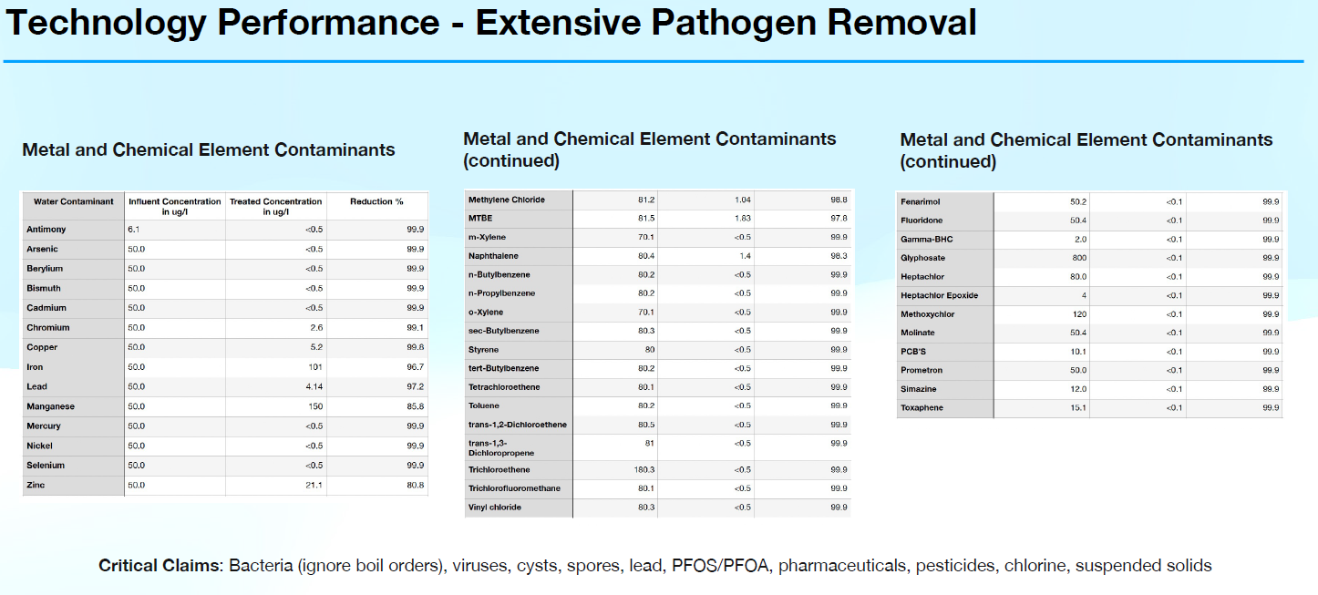

(Graphic C – NSF.Checklist.jpg)
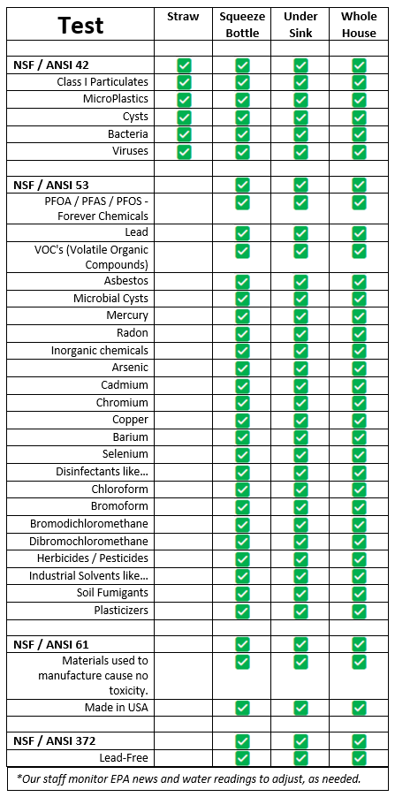

Forever Chemicals: PFOS/PFAS/PFOA: EPA is committed to supporting states and public water systems as they determine the appropriate steps to reduce exposure to PFOA and PFOS in drinking water.
What are Forever Chemicals?
Perfluorooctanoic acid (PFOA) and perfluorooctane sulfonic acid (PFOS). PFOA and PFOS are members of a chemical group called per- and polyfluoroalkyl substances (PFAS).

Toxicity: Studies indicate that exposure to PFOA and PFOS over certain levels may result in adverse health effects, including developmental effects to fetuses during pregnancy or to breastfed infants (e.g., low birth weight, accelerated puberty, skeletal variations), cancer (e.g., testicular, kidney), liver effects (e.g., tissue damage), immune effects (e.g., antibody production and immunity), thyroid effects and other effects (e.g., cholesterol changes).

Treatment: GAC has been shown to effectively remove PFAS from drinking water when it is used in a flow through filter mode after particulates have already been removed. EPA researcher Thomas Speth says, “GAC can be 100 percent effective for a period of time, depending on the type of carbon used, the depth of the bed of carbon, flow rate of the water, the specific PFAS you need to remove, temperature, and the degree and type of organic matter as well as other contaminants, or constituents, in the water.”
Another type of activated carbon treatment is powdered activated carbon (PAC) which is the same material as GAC, but it is smaller in size, powder like. Because of the small particle size, PAC cannot be used in a flow through bed, but can be added directly to the water and then removed with the other natural particulates in the clarification stage (conventional water treatment or low-pressure membranes - microfiltration or ultrafiltration).

Source: 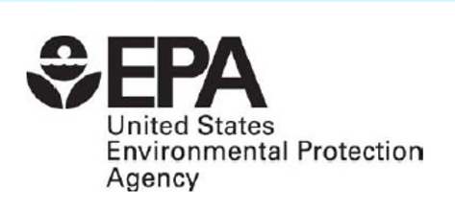

EPA proposes UCMR 6 monitoring rule, leaves microplastics off testing list – July 6, 2026: Hyperlink https://www.waterworld.com/drinking-water-treatment/news/55388787/epa-proposes-ucmr-6-monitoring-rule-leaves-microplastics-off-testing-list
The EPA's proposed UCMR 6 mandates monitoring for 30 unregulated contaminants in public water systems from 2028 to 2030.
The U.S. Environmental Protection Agency (EPA) has proposed the sixth Unregulated Contaminant Monitoring Rule (UCMR 6), requiring public water systems to monitor for 30 unregulated contaminants between 2028 and 2030 to better understand their occurrence in drinking water systems nationwide. While the proposal expands monitoring for several emerging contaminants, EPA opted not to include microplastics, citing the lack of a validated analytical method capable of producing nationally consistent monitoring data.
Under the proposed rule, community water systems and non-transient non-community water systems serving more than 3,300 people would be required to monitor for all 30 contaminants. EPA would also select a representative sample of smaller systems serving 3,300 or fewer people to participate. The contaminant list includes seven ultrashort organofluorine compounds, including several PFAS, three pesticide metabolites, 13 semivolatile organic compounds and seven purgeable organic compounds. The agency said the resulting occurrence data will help determine whether additional contaminants warrant future regulation under the Safe Drinking Water Act.
Read Full Article Hyperlink

Notable exclusions: EPA specifically considered, but did not include, several high-profile contaminant groups:

Microplastics — excluded because EPA determined there is no validated national analytical method suitable for UCMR monitoring, despite petitions from seven governors and environmental organizations requesting their inclusion.
Pharmaceuticals — EPA also evaluated pharmaceuticals for UCMR 6 but ultimately did not include them in the proposed monitoring list.

--- --- --- --- --- --- --- --- --- --- --- --- --- --- ---
Air Science should be same.
CleanAir machines have been used and tested for decades in many rough environments, with A+ passing grades – Earth, Space, FDA Certified Class II Medical Device (Air), CDC, DoD and many more. The Air technology is how plants were grown in Space.
(Below: Hyperlinks from Title of item listed here – many abbreviated – add graphics staggered like Home Page)

AIR MACHINES:

FDA Class II Medical Device Approval: (A-FDAClearanceLetter-2020)

NASA-Based Technology® Rapidly Reduces 99.9% of Airborne SARS-CoV-2 Virus in FDA-Compliant Military Lab Tests
(NASA-Based…-2020.PDF; in SciAir Folder)

Air-on-Surface:
(PDF, in SciWater Folder)

Active Peer-Reviewed Study, American Journal of Infection Control:
https://www.ajicjournal.org/article/S0196-6553(24)00155-X/fulltext

Kansas State Testing results:
https://vollara.blob.core.windows.net/resources-prod/Air/Air%20Research/Testing%20Charts_1011.pdf

Results for Inactivation of L Pneumonia:
https://vollara.blob.core.windows.net/resources-prod/Air/Air%20Research/TestResultsforAerusLLC_inactivationofLpneumophila(Fresh%20Air)_final_Redacted.pdf

American Journal of Infection Control, HAI’s:
(PDF, in SciWater Folder)

EPA Requires Schools to Improve Indoor Air Quality:
https://www.epa.gov/iaq-schools/take-action-improve-indoor-air-quality-schools

SARS-CV2 and Other Infectious Disease:
(PDF, in SciWater Folder)

Fresh Air Petri Dish:
(PDF, in SciWater Folder)

Candida Yeast and pH:
(PDF, in SciWater Folder)

