The Products
CleanWater
Product
CleanAir
Products
Hyperlink to below - Hyperlink to below – Air
Water Products Products

Our Systems Pay for Themselves

Does your home have poor water quality? Ever see a boil order? Have you properly tested your water for parasites, pathogens, virus, bacteria, spores, cysts, microplastics, PFAS, lead, mercury, arsenic, radon, asbestos, pesticides?
Our systems are designed to keep you and your loved ones healthy. Add our products piece by piece or all at once, easy plug-n-play. Our products resolve 99.9999% of water issues. We score well on health issues too, when you drink (enough) quality water. Delicious and nutritious.
Improving your budget, reducing expenses, improving your health, eliminating significant chemical exposures, plastic bottle trash, time and energy to create the plastic piles. One simple fix.

CleanWater on tap, free and anytime in abundance.

Help us CLEAN the environment together: CleanWater.

[Video on Simple, Math, Science and Wellness]
You may be qualified for a subsidized system.
Check your local water quality, EPA standards and reports.
There are no ‘allowable toxins’ unless you like gambling with your health.

Our CleanWater products create the cleanest and smallest water molecules, enabling super-instant hydration and energy, abundantly from your tap. Our systems are designed to add the nutrients and taste that was processed out of your water before finding your tap.
[Whole House water video]

Other technologies:

- Create wastewater
- Dump it back into the environment.
- Cannot claim to clean water as well as we do
- Were not chosen as best in the galaxy.

We are the only product ACTUALLY removing toxins from the environment. Other products collect and release them in wastewater streams. We have no wastewater.

Our systems exist in a place where physics meets chemistry. By re-structuring each molecule and re-conditioning the (nutrients processed out of) water with natural minerals and micro-nutrients, your water tastes better. Your mind and body will function better.
Our CleanWater products deliver real and measurable improvements in health, energy, mental clarity, well-being, cost-savings, energy efficiency, diverse uses and sustainability. Reduce your expenses, chemical reactions, plastic bottles; while improving hydration, budget and general health.

All water in America has ‘allowable toxins’, per EPA and municipal water testing.
We remove all toxins and pathogens down to 20 nm.
We provide the solution to ensure you never wonder if your water is safe.
Our water systems work on Well Water and Municipal Water Systems.
Our systems can be scaled to any size.
Contact our Engineering department for larger system designs - Water and Air Systems.

Water Products – This is the order of lay-out. Many duplicates, hyperlink from summary view.
I’ll make a list of products and their Pages.
-Personal
-Residential hyperlink
-Commercial – Industrial hyperlink to Comm-Industrial
Municipal - Custom hyperlink to Comm-Industrial
Toppen products will run thru Shopify. Vollara Products remain in separate check-out.

(Click on hyperlinks above &…remove green notes – scroll all products below)

Water Products (T) = Toppen, (V) = Vollara
Personal
-Straws (T)
-Squeeze Water Bottle (T)
-Metal Water Bottle (T)
-Emergency Kits (T)
-LivingWater Machine (V)
-H2 Fuel (V)
-LaundryPure (V)
-Nutrition (V)

Residential – Small Business
-Whole Home Package – 5-10, 10-20, 20-40 GPM; WW & MW = 6
-Whole Home Deluxe Package - 5-10, 10-20, 20-40 GPM; WW & MW = 6
-Whole Home Units – Choose Well Water or Municipal, Size (GPM – chart) = 6 (T)
-Under Sink (T)
-LivingWater Machine (V)
-LaundryPure (V)
-Emergency Kits (T)
-Straws (T)
-Squeeze Water Bottle (T)
-Metal Water Bottle(T)
-H2 Fuel (V)
-Electricity (V)

Commercial – Industrial - Municipal
-Whole House Units – Choose Well Water or Municipal, Size (GPM – chart) (T)
-Under Sink (T)
-LivingWater Machine (V)
-LaundryPure (V)
-Emergency Kits (T)
-Straws (T)
-Squeeze Water Bottle (T)
-Metal Water Bottle(T)
-Custom Sized units scaled to any capacity. Contact Us for specific design.

Each Toppen Product will have:
-Product Summary, Description for web, image
-Product Sheet - PDF
-Science - link to Toppen Water Science
-Installation & Maintenance – PDF
-Purchase Hyperlink to purchase
-Filter Replacement, ReOrder – Hyperlink to purchase manually. Upon ordering initial product, name-email-product # and Quantity in database for email reminder at 10-11 months. Click a check-box (or automatically select to be deselected?) to ‘Automatically send replacement filter’ at 10 months.

Is it possible to arrange the products on site like this? And have them open into a specific Product Page? I am not sure what the 3 gray rectangles are at each, but cannot delete it. Please delete it if it shows.

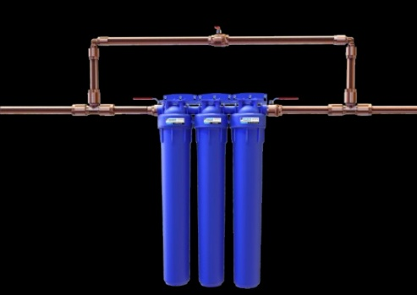 | Product Description:  View More  Drop into Product Page  SKU T-50101-01 Shop | Ultra Home  UltraSafe SS System – Well Water  UltraSafe SS System™  Filtration System for Under 5 - 10 GPM  Product Sheet – Science – Installation / Maintenance  Order Filters – Order Cleaning Kit Hyperlinks to EA
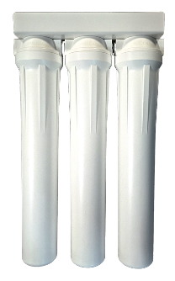 | Product Description:  View More  Drop into Product Page  SKU T-50202-01 Shop | Ultra Home  UltraSafe SS System – Well Water  UltraSafe SS System™  Filtration System for Under 10 - 20 GPM  Product Sheet – Science – Installation / Maintenance  Order Filters – Order Cleaning Kit Hyperlinks to EA
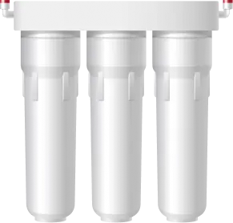 | Product Description:  View More  Drop into Product Page  SKU T-50403-01 Shop | Ultra Home  UltraSafe SS System – Well Water  UltraSafe SS System™  Filtration System for Under 20 – 40 GPM  Product Sheet – Science – Installation / Maintenance  Order Filters – Order Cleaning Kit Hyperlinks to EA

Air Products (same; run-on list)
-Personal
-Residential
-Commercial - Custom
Vollara products will remain same (2 check-outs), except... Air - Remove AP-500. I have no graphic and it’s
nothing compared to the Pro XL.
I’ll summarize a list of specific products for Air, Laundry, Electricity, Nutrition.
Products area will be run-on list of ‘Main Product Searched’ with other products behind and mixed and repeated
(3 times?) – long scroll.

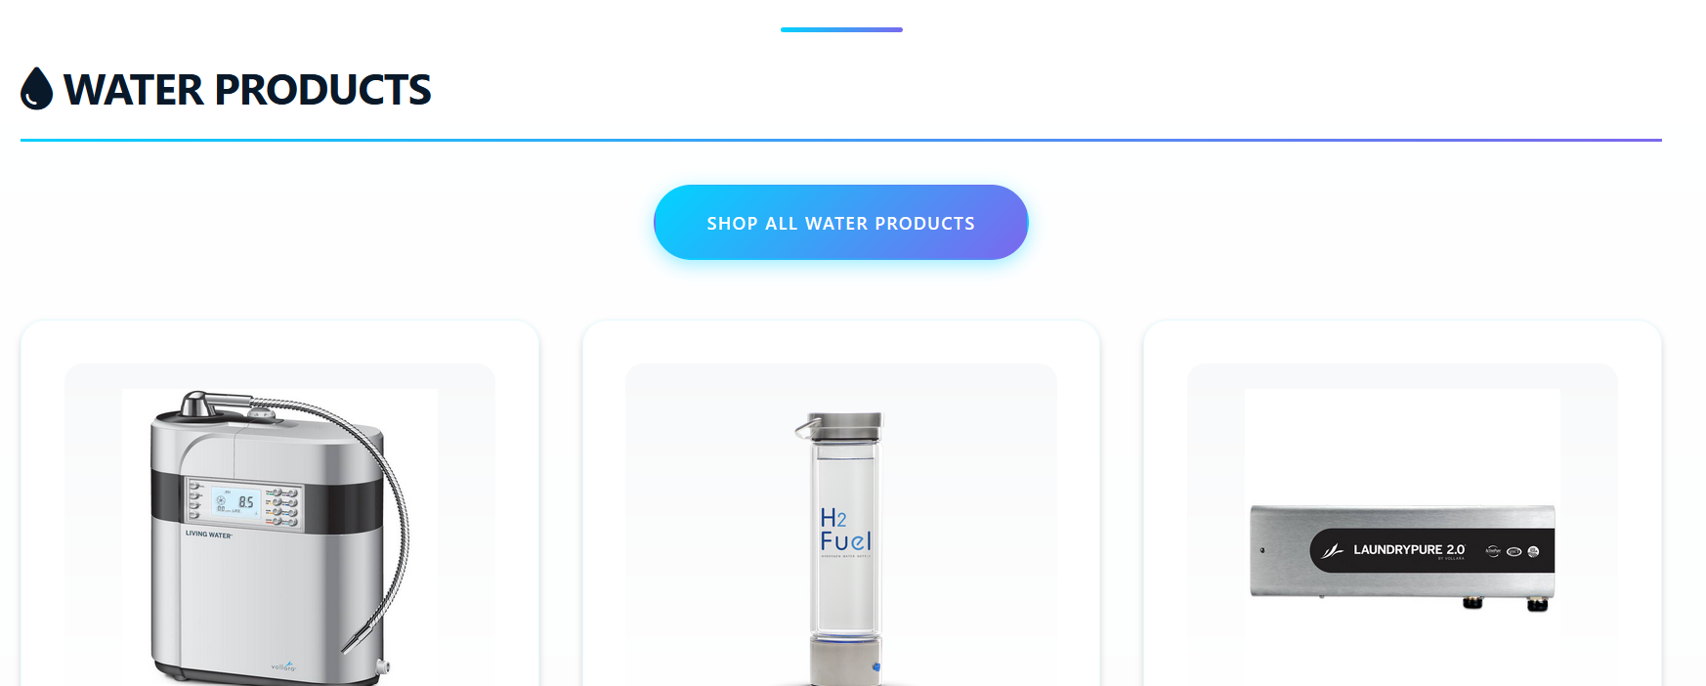
Revise Water Products to Display as shown below:
Personal
Residential – Small Business
Industrial - Municipal

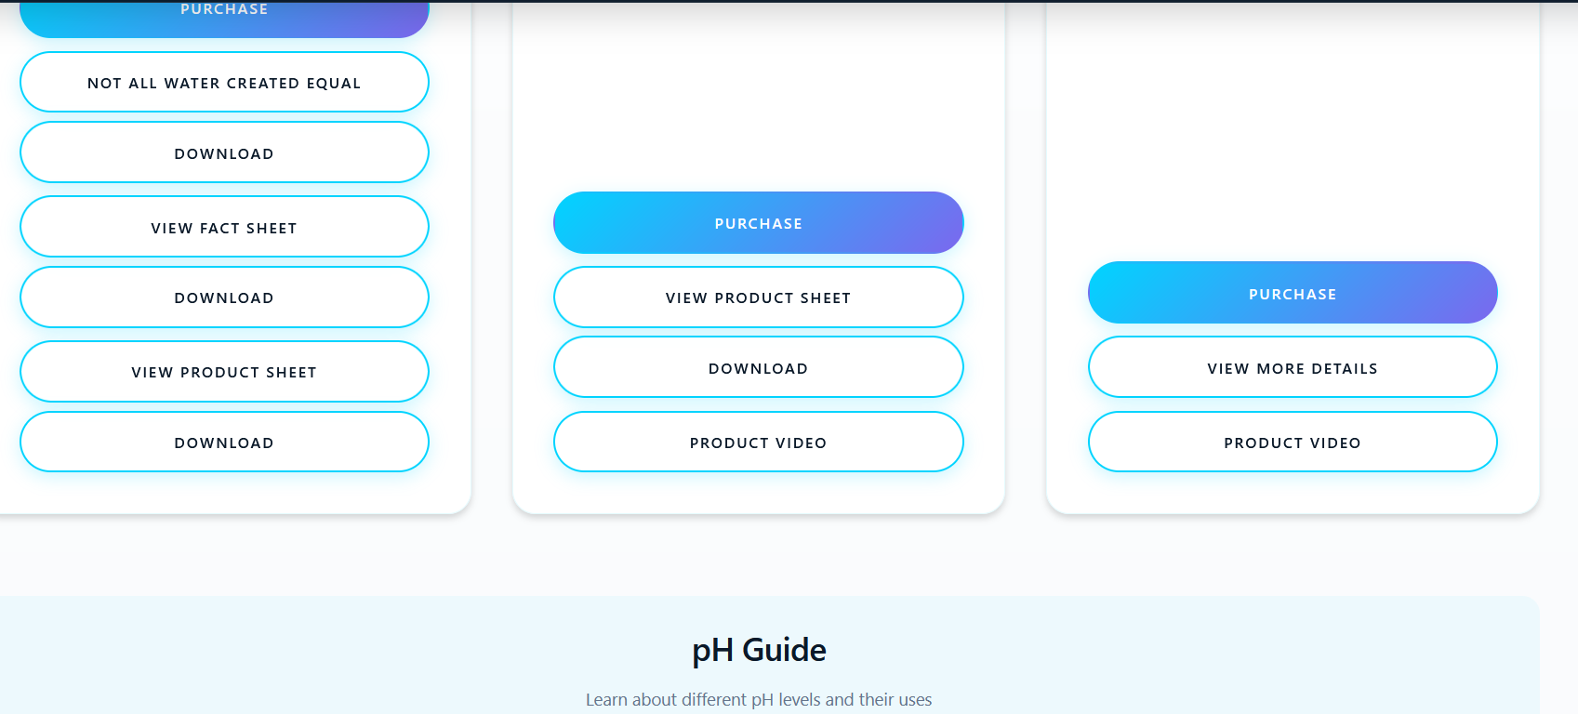
Can these be stacked so there’s no space between product and hyperlink buttons: Purchase, Product Sheet, Fact Sheet, Installation, Filter ReOrder?
…Remove Download and hyperlink-download to button.

If we re-arrange products as exhibited from previous page, these weird-spaces will be gone.
I’m guessing we will have to shrink columns, but I can preview things in Amazon and would
like to come close to matching that format. Click to View More.

