The Air Products
CleanWater
Product
CleanAir
Products
Hyperlink to Hyperlink from above – Air
Water Products Products

Our Systems Pay for Themselves

Preventing illness is one of your best investments. How many poor air quality days per year? How many high allergy days per year? Discover our air products and escape these inconveniences. Rid yourself of unwanted odors – plug in any of our Air machines.
Our systems are designed to keep you and your loved ones healthy. Our products resolve 99.97% of air quality and freshness issues. Our products also eliminate 99.97% of pathogens on surfaces.
Our products:
Improve your budget
Reduce your expenses
Improving your health
Eliminate significant chemical exposures
Is it possible to arrange the products on site like this? And have them open into a specific Product Page? I am not sure what the 3 gray rectangles are at each, but cannot delete it. Please delete it if it shows.

Eliminate pathogens
Save time and energy lost on fighting illness.
….We get that back for you.

CleanAir, free and anytime in abundance.

Help us CLEAN the environment together: CleanAir.

[Video on Air - Office]
Contact our Engineering department for larger system designs - Water and Air Systems.

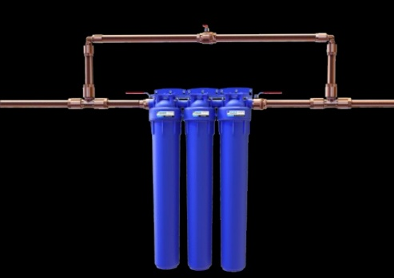 | Product Description:  View More  Drop into Product Page  SKU T-50101-01 Shop | Ultra Home  UltraSafe SS System – Well Water  UltraSafe SS System™  Filtration System for Under 5 - 10 GPM  Product Sheet – Science – Installation / Maintenance  Order Filters – Order Cleaning Kit Hyperlinks to EA
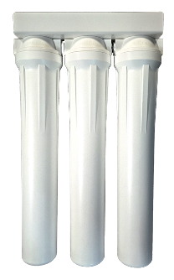 | Product Description:  View More  Drop into Product Page  SKU T-50202-01 Shop | Ultra Home  UltraSafe SS System – Well Water  UltraSafe SS System™  Filtration System for Under 10 - 20 GPM  Product Sheet – Science – Installation / Maintenance  Order Filters – Order Cleaning Kit Hyperlinks to EA
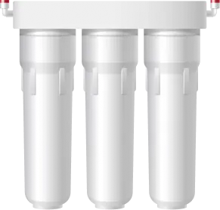 | Product Description:  View More  Drop into Product Page  SKU T-50403-01 Shop | Ultra Home  UltraSafe SS System – Well Water  UltraSafe SS System™  Filtration System for Under 20 – 40 GPM  Product Sheet – Science – Installation / Maintenance  Order Filters – Order Cleaning Kit Hyperlinks to EA

Air Products (same; run-on list)
-Personal
-Residential
-Commercial – Custom

-Personal
Fresh Air Personal – Product Video: https://vimeo.com/582672357/0fba929bed
(FreshAirPersonal -ProductSheet.PDF)
(Graphic from Air-Above)
Personal Mobile – Product Video: https://vimeo.com/611977146/d4ed79b590
(PersonalMobileDevice.PDF)
(Graphic from Air-Above)
Personal Mobile Rechargeable – Product Video: https://vimeo.com/867186117

-Residential
Surface Pro XL – Product Video: https://vimeo.com/831617749
(XL Fact Sheet.PDF)
(XL Product Sheet.PDF)
Fresh Air Personal – Product Video: https://vimeo.com/582672357/0fba929bed
(FreshAirPersonal -ProductSheet.PDF)
(Graphic from Air-Above)
Pet Refresh - (PetRefresh-ProductSheet.PDF)
(Graphic from Air-Above)
Personal Mobile – Product Video: https://vimeo.com/611977146/d4ed79b590
(PersonalMobileDevice.PDF)
(Graphic from Air-Above)
Personal Mobile Rechargeable – Product Video: https://vimeo.com/867186117

-Commercial - Custom
Contact our Engineering department for larger system designs - Water and Air Systems.

Summary of Air Units:
Air Product Tech: "JK-Vollara_AP Tech_PC_Explainer.pdf"

Surface Pro XL – Product Video: https://vimeo.com/831617749
(XL Fact Sheet.PDF)
(XL Product Sheet.PDF)

Surface Pro Plus - (SurfaceProPlus-ProductSheet.PDF) – Remove this product.
(Graphic from Air-Above)

Fresh Air Personal – Product Video: https://vimeo.com/582672357/0fba929bed
(FreshAirPersonal -ProductSheet.PDF)
(Graphic from Air-Above)

Pet Refresh - (PetRefresh-ProductSheet.PDF)
(Graphic from Air-Above)

Personal Mobile – Product Video: https://vimeo.com/611977146/d4ed79b590
(PersonalMobileDevice.PDF)
(Graphic from Air-Above)

Personal Mobile Rechargeable – Product Video: https://vimeo.com/867186117

