How Does It Work?
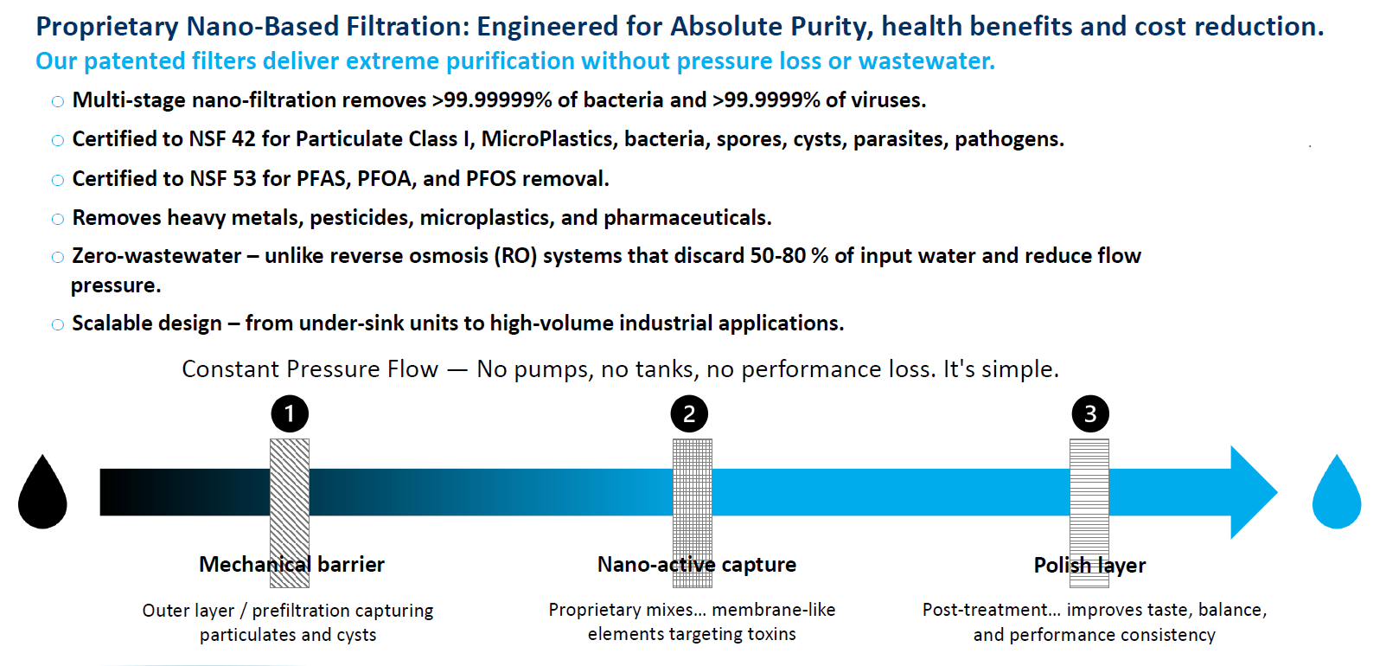
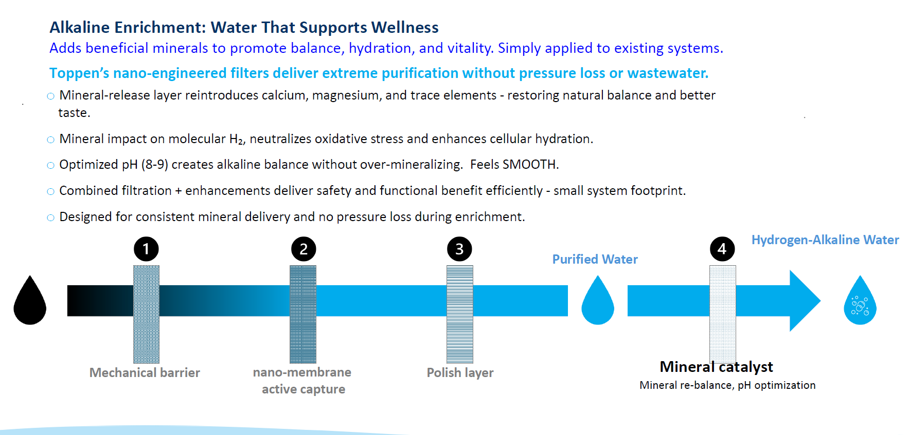

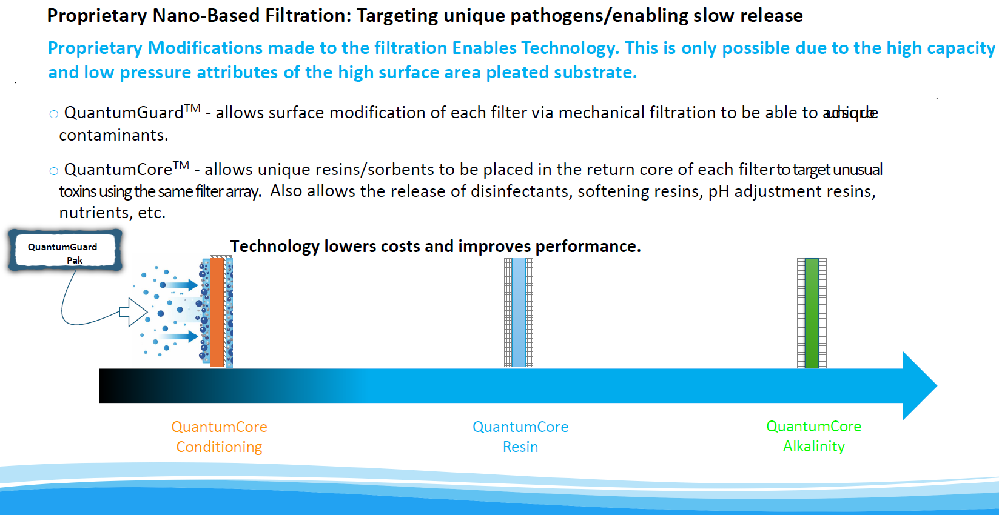
Adds minerals and micro-nutrients
Whole-Home Water. Reengineered. Hyperlinked to Whole Home Video
Designed for Municipal and Well Water Supply
The Facts
•99.9999999% bacteria removal (>9 LRV*)
•99% reduction of heavy metals (97.2% lead reduction)
•95% reduction of PFAS (forever chemicals, PFOA/PFOS)
•Anti-scale filter to treat hard water
•No water softener needed
•No heavy bags of salt
•No salinized wastewater
•Reduces the scale buildup on faucets, cookware, appliances; leave good minerals in water
•Particulate reduction down to 20 nm.

Step 1 - Uses a multi-faceted filter, removing large particles - greater than 5 micron. Simultaneously conditioning the incoming water so it can no longer form calcium carbonate – no more spots when cleaning, dishes, silverware. This filtration process extends the life.
MicronGuard™ our next stage, filters out sediment. Conditions water so glasses and faucets remain spotless.

Step 2 - Uses our proprietary MicronGuard™ filter, removing bacteria, viruses, cysts, spores, and other pathogens. Engineered with an activated carbon high surface area paper reduces pathogens, pesticides, pharmaceuticals, forever chemicals (PFOA/PFOS), and heavy metals (including lead). We incorporate Agion silver particles preventing the filter from biofouling.

Step 3 - Stage 3 is the Final polishing of PFOA/PFOS, lead, chlorine, pesticides, and other contaminants with a high-capacity carbon filter. This improves taste and smell of water. This carbon will outperform similar carbons due to the purity of water at this step of the process.

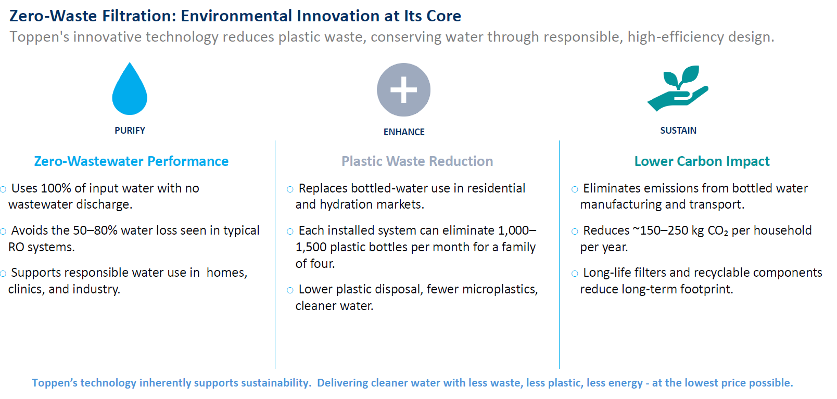
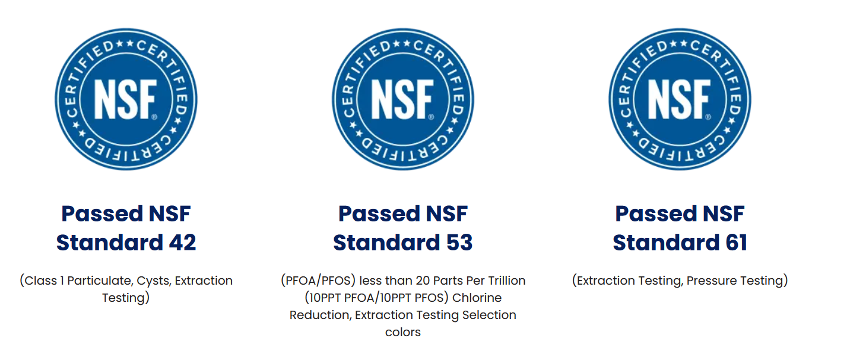
Step 1: Proprietary Nano-Based Filtration – MicronGuardTM:
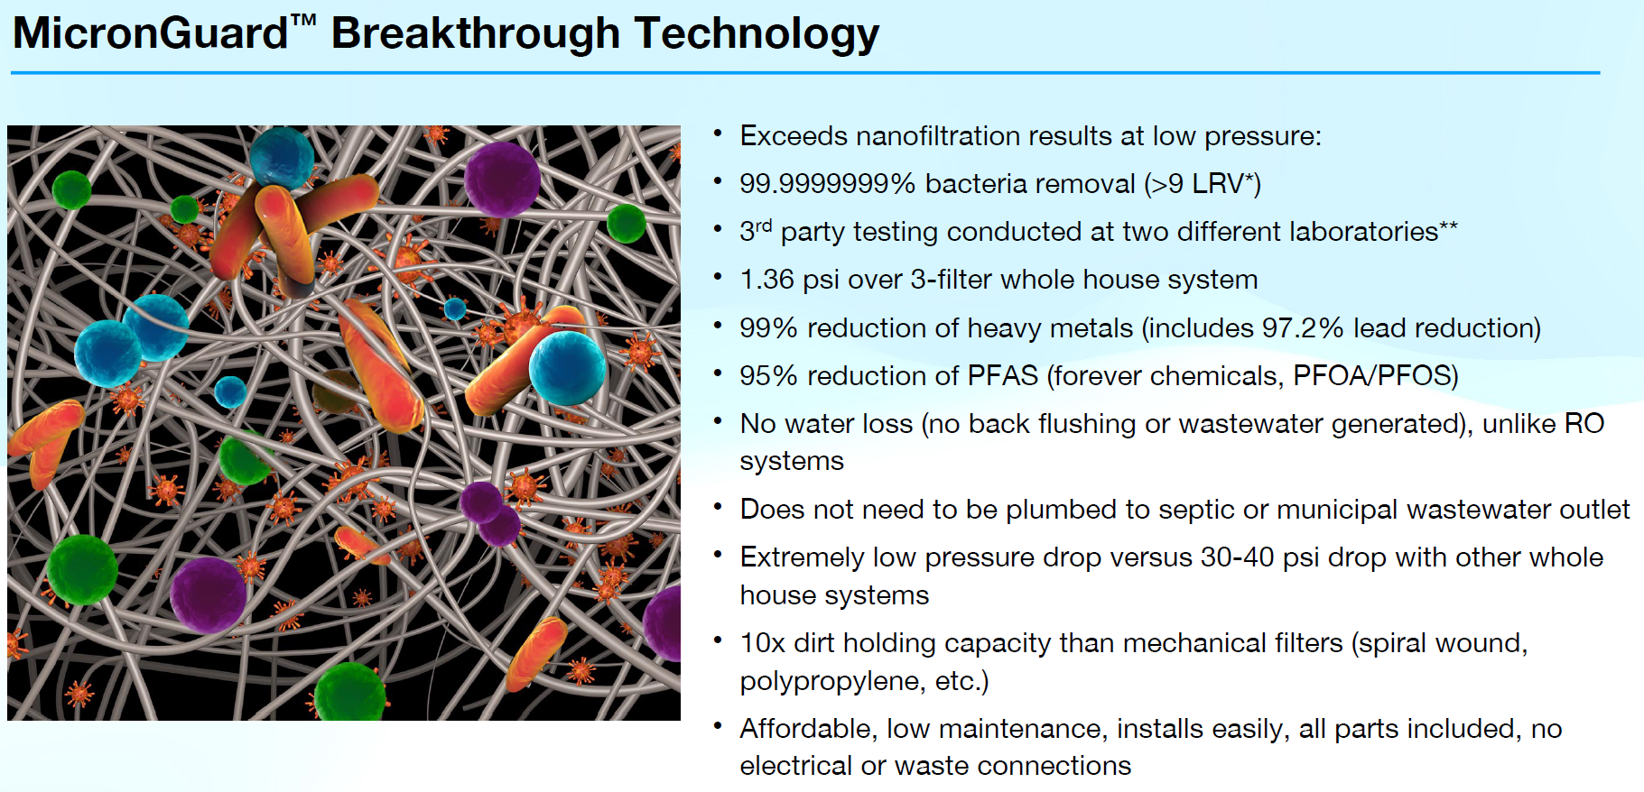

Step 2: QuantumGuardTM & QuantumCoreTM:

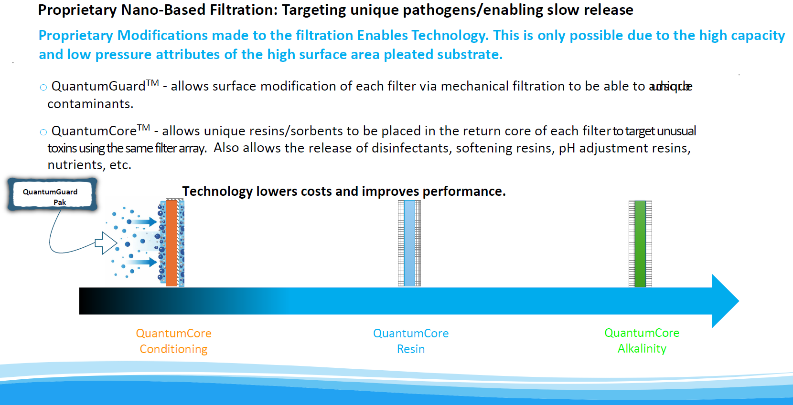
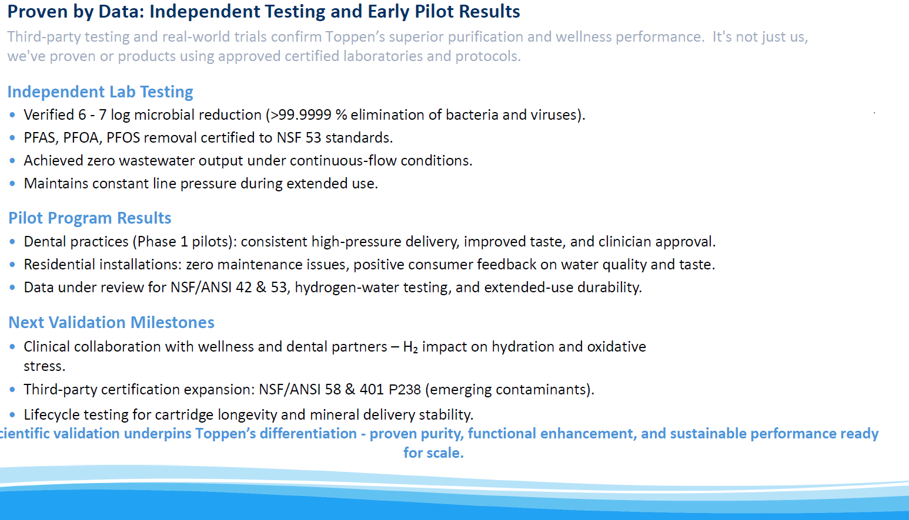

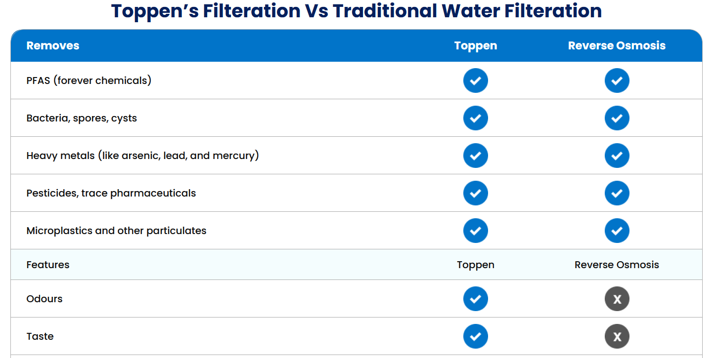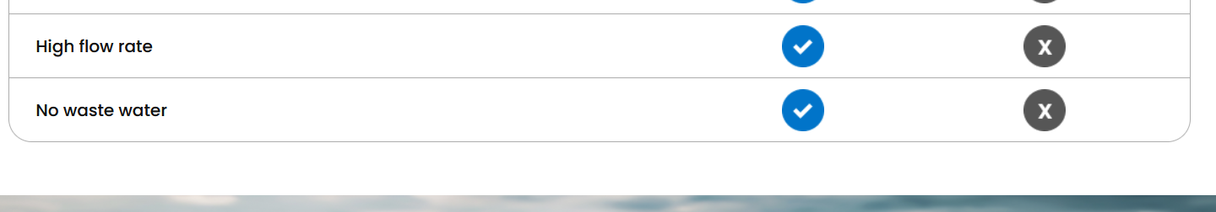
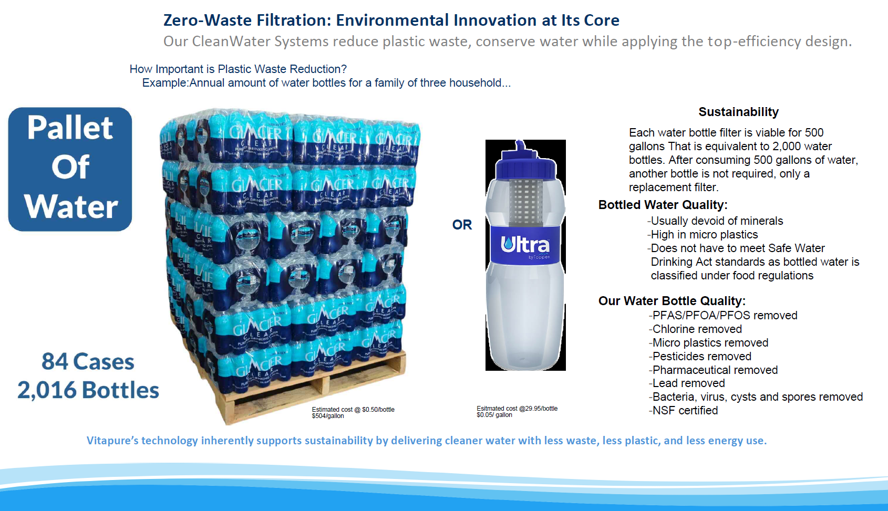

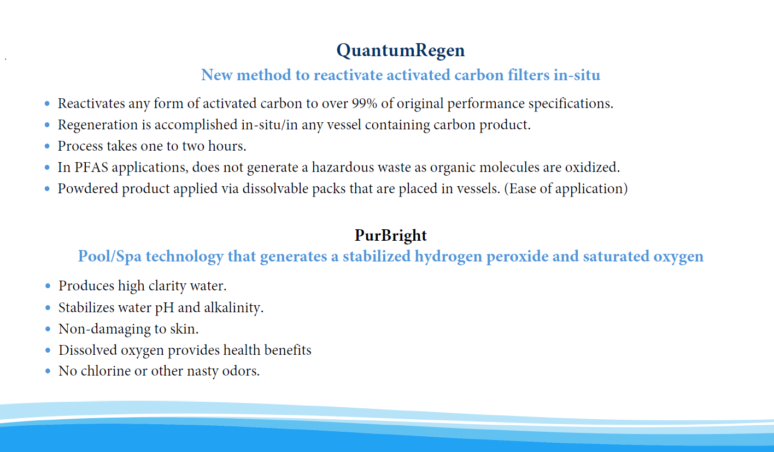

For waste-water systems and reducing waste-water fines and fees.

