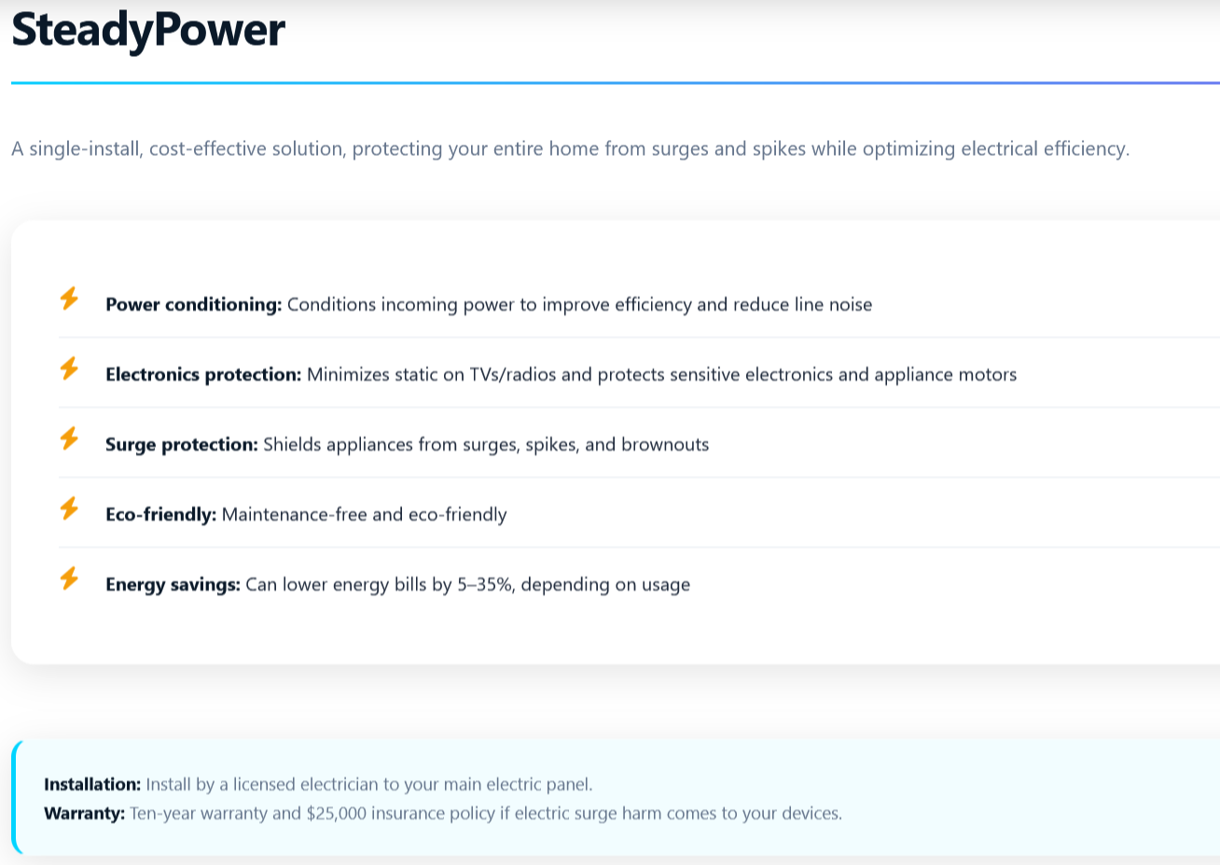
Reduce space between and increase font here. Move to match $10,000…$25,000 Bullet List below.
Replace first line (below) with first paragraph (further below the screenshot of website.)
Replace first line (below) with first paragraph (further below the screenshot of website.)

Replace first line with: SteadyPower is a whole house surge protector.
- 10-year warranty
- $25,000 insurance policy if electric surge causes harm to your devices.

SteadyPower is designed to ‘clean up electricity’ – removing the static that disrupts efficiency in your device and appliance motors. Healthier for your devices and appliances, extending their life and health.
SteadyPower users have experienced a 5-35% savings on their electric bill. Removing electric chaos from your electric supply to devices and appliances extends their life. Run the math and you will see it pays for itself (long) before the warranty expires.
Useful for lightning surges, browning or brown-out areas. The security provided with whole home protection from electrical surge or browning – PRICELESS!!!
Purchase
button

