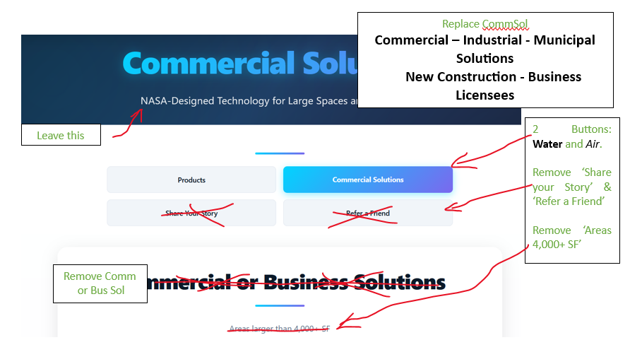

Balance Title block like below…
Commercial – Industrial - Municipal Solutions
New Construction - Business Licensees
Engineers on Staff to Assist
Stack buttons for iToys

INDUSTRIAL, MUNICIPAL,
NEW CONSTRUCTION and DATA CENTERS

RESIDENTIAL and SMALL BUSINESS
Based on GPM = Gallons Per Minute, your water demand

Hyperlink to below.

(Whole House graphic - video)

Our Systems Pay for Themselves – Have PFAS, lead, mercury, arsenic, microplastics, radon, asbestos, pesticides, pharmaceuticals in your water? Chances are the answer is; Yes. When it is ‘No’, it was not tested or the wrong test was used. 99% of people have ‘allowable toxins’ in their water.
Our systems are designed for you to add them at your liesure or all at once; easy plug-n-play. Our products resolve 99.9999% of water issues. We score well on health issues too, when you drink (enough) quality water. Delicious and nutritious.
Improving your budget, reducing expenses, improving your health, saving you time and energy – shopping, carrying, stocking, disposing of bottled water. One simple fix. CleanWaterCleanAir.

Compare – Plastic Bottled Water -or- a Whole Home System

Whole Home System – Average Pricing
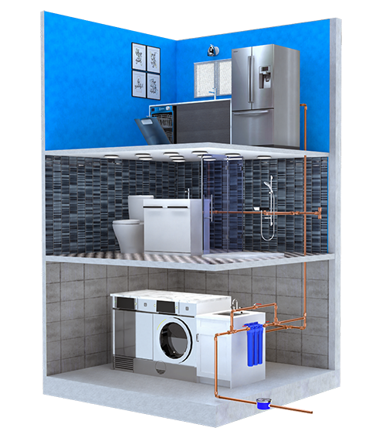

Whole House (1, at entry): $1,899 to $2,299.
Depends on GPM = Gallons per Minute,
using largest of Standard Size system.
Pricing based on 1 kitchen + 3-bath sinks and 2 showers.
Fewer baths/showers = less expense.

UnderSink (4 sinks): $525 each x 2. = $1,050.

Shower (2): $325 each x 1. = $325.

Subtotal of equipment: ~$3,647.
(assuming larger whole house system)
Plumbing is basic and should run ~$1,000.
Plumber/Skills only necessary for Whole House bi-pass system.

TOTAL PROJECT: under $5,000.
A permanent solution. One cost.
Stress reduction = PRICELESS.
When you look forward to healthy showers and cost-effective budgeting beyond 2 years. SOLUTION.
Plastic Bottle Water – Average Pricing
One person = ~2,000 bottles of water per year. If (poor quality) 35 cents/bottle =
…$700/year/person.

Plus health affects: lethargy, acid reflux,
acid water, achy body, brain fog?

A family of 4 will bring that cost to $2,800/year.
…plus health affects…

Bottled water only covers drinking.
Not showers, dishes, cleaning, handwashing, exposure?

What is the health cost, to wash or not to wash?
$2,800/year – for how many years?
+ inconvenience and unwellness.
Temporary band-aid, not a solution.
Ongoing problem = stress.

-OR-

You may be qualified for a subsidized system.
Check your local water quality and EPA standards and reports.
There are no ‘allowable toxins’ unless you like gambling with your health.
Hyperlink from P. 1 - I, M, NC & DC

INDUSTRIAL, MUNICIPAL,
NEW CONSTRUCTION and DATA CENTERS

(Industrial Municipal Video)

CleanWaterCleanAir.com supplies affordable systems for clean water and clean air systems for EVERYONE. All cities and towns have ‘allowable toxins’ in their water. We believe a toxin is a toxin and not allowable.
Our systems eliminate PFAS, PFOA, PFOS, bacteria, cysts, spores, pharmaceuticals, pesticides, heavy metals and particulates down to the nanoscale. Filter modifications allow the systems to target arsenic and nitrates as well.
Our systems can be engineered for many flow rates and contaminant variables. They can be skid-mounted, containerized or simply delivered as components. If you provide a water test, custom adjustments can be made – adapting to your water concerns.

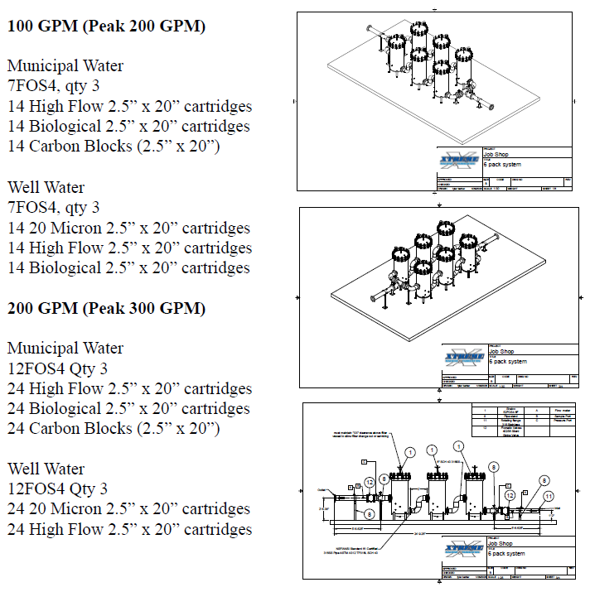

As new toxins emerge, our research department receives and researches new and emerging issues daily. We stay informed and up to date on any new patterns or toxins of all types to remain ahead of evolution.
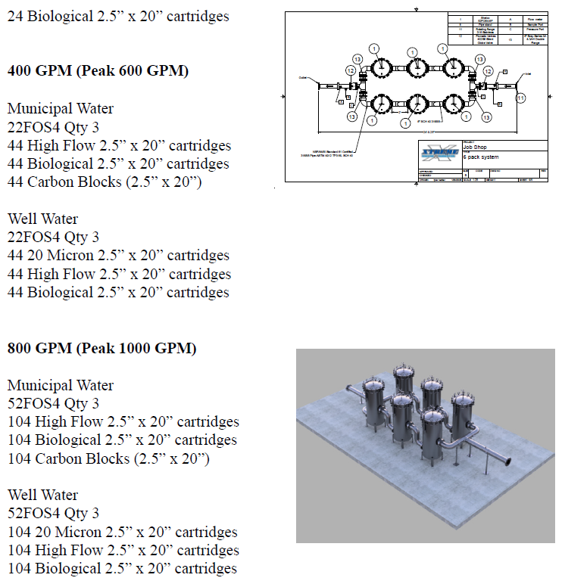
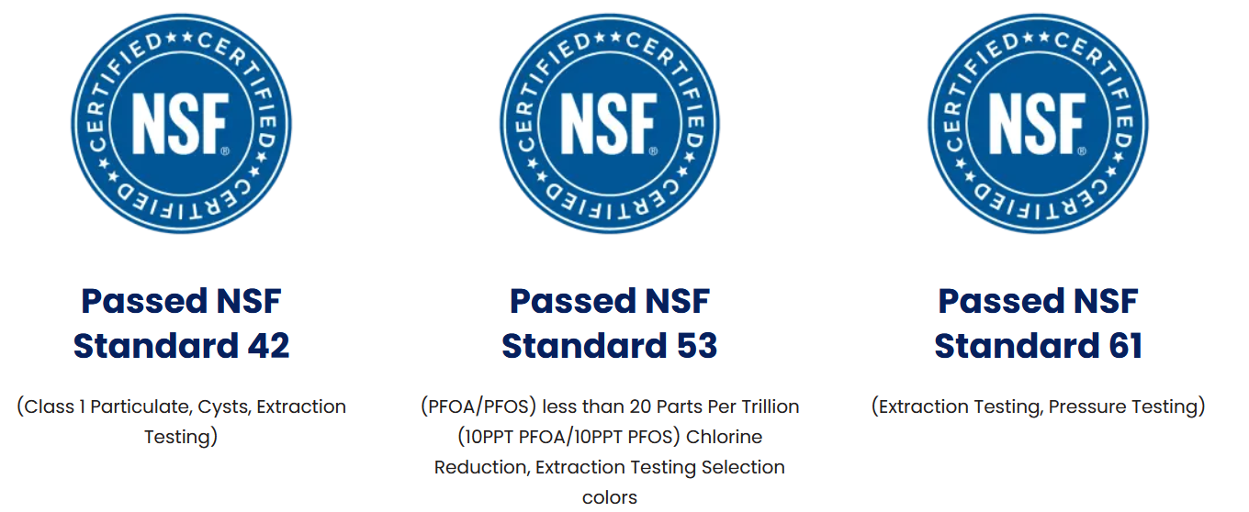
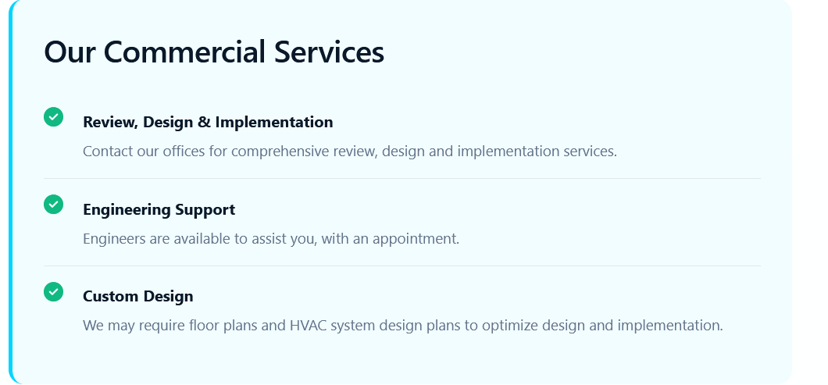

…followed by a ‘Contact Us Box’ (to ‘add email, subject, note, phone, name - Send)
Please contact our Engineers for a custom design. We can be reached at:

Email: MoreInfo.CWCA@gmail.com
Phone: TBD
Address: 1770 Massachusetts Ave. #316
Cambridge, Mass. 02140

Give us a brief description of your needs.

