HOME PAGE

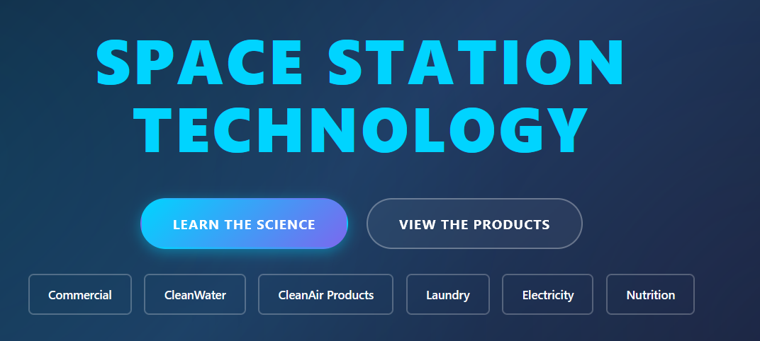
Shop
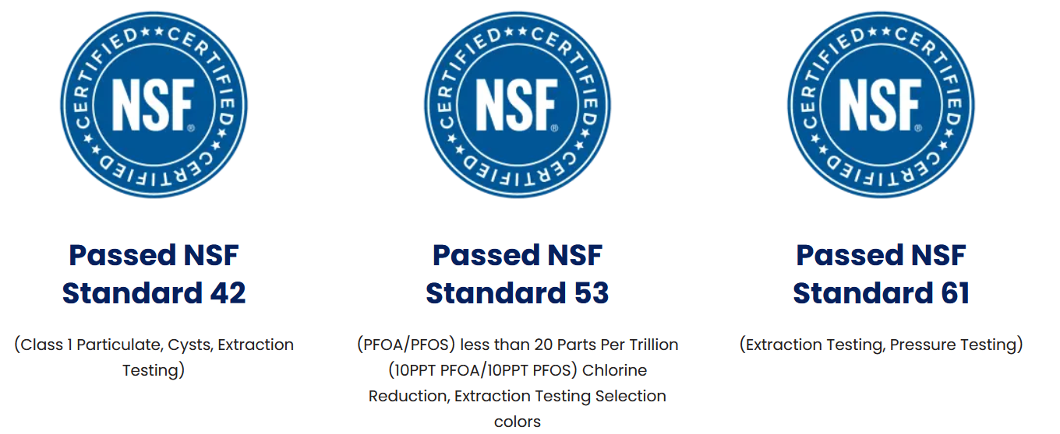

(Above) View Science or View Products – top buttons. Each to drop into 2 options: CleanWater or CleanAir

Below that,
Top Nav-bar on Home Page: CleanWater – CleanAir – Commercial/ Industrial - Electricity – Nutrition – Shop (Drops
into run-on Product List, Water, then Air, Electricity, Nutrition - shuffled and repeat.) (Laundry under Water)

When click on CleanWater or CleanAir; 2 options: Science – Products- each segregated to specific science – Products, Toppen (T) or Vollara (V).
(Two option-hyperlinks)
(1)Household and Commercial - Toppen
(2)Dialing Water pH – Vollara - Household
Commercial / Industrial –->
-Commercial / Residential --- Water, then Air products
-Commercial / Industrial / Municipal - Water, then Air products
(will lay these topics out Later …Layer 2 - Products)

-CleanWater will have both Vollara & Toppen products, Air is only Vollara…will
break up later in this doc., product specific pages

Home Page (text): CleanWaterCleanAir is here to bring Space Station Technology home - for your Business, Home and Personal Use. Clean Water and Clean Air - NASA- technologies are used by:
International Space Station (to grow plants)
Department of Defense
Military
Medical and laboratory environments
Professional Sports Teams
Astronauts and Space Program
Health and Wellness

Our CleanAir systems are an FDA tested and approved Class II medical device. They eliminate 99.9% of pathogens in air AND ON SURFACES. It is the ONLY ACTIVE air AND SURFACE purification system on the market.

Our products promote health in space and on Earth.
[Kid-Straw-Video – YouTubeLink – open in new window?]

Simple Math, Science and Wellness - Municipalities and water testing have a category called ‘Allowable Toxins’. We do not believe any toxin is allowable. Many toxins and chemicals are not required testing. We solve the question marks with CleanWater: WATER SAFETY and WATER SECURITY.
NSF / ANSI 42 - Filters are certified to reduce aesthetic impurities such as chlorine and taste/odor: Point-of-use (under the sink, water pitcher, etc.) or point-of-entry (whole house) treatment systems.

NSF/ANSI certifications: 42, 53, 61, 372 hyperlink to Science
No wastewater.
High flow.
Center if imbalanced
No pressure loss.
Removes PFAS and forever chemicals
Removes bacteria and viruses
Removes parasites, spores, cysts
Removes microplastics
Removes heavy metals: lead, mercury
Removes pesticides
Removes pharmaceuticals
Removes chemicals, chlorine and more.
LOW maintenance, one filter change per year.

NSF / ANSI 53 - Filters are certified to reduce a contaminant with a health effect. Health effects are set in this standard as regulated by the U.S. Environmental Protection Agency (EPA) and Health Canada. Both standards 42 and 53 cover adsorption/filtration which occurs when liquid, gas or dissolved/suspended matter adheres to the surface of, or in the pores of, an adsorbent media. Carbon filters are an example of this type of product.

NSF / ANSI 61 – Materials used to manufacture cause no toxicity.

NSF / ANSI 372 – Lead Free.

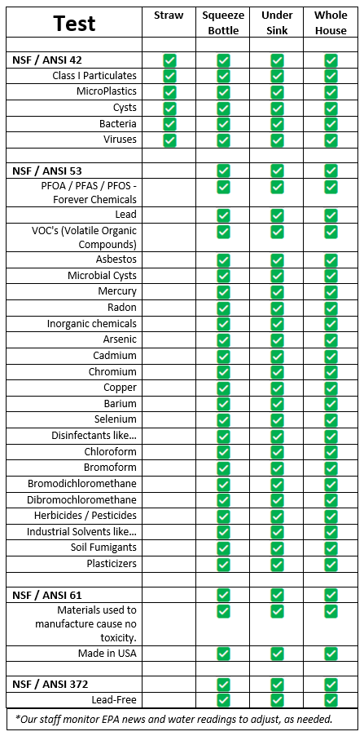
Break line.
- See more? –
Link to Pix B, C, D sequence. Will be loaded into Science.
Break line.
- See more? –
Link to Pix B, C, D sequence. Will be loaded into Science.
Click here for a more detailed list, SOLUTIONS.
Hyperlink to ToppenScience

Learn your water tests for your neighborhood. Type your zip code:
I’ll collect a hyperlink we can use. Would like to keep traffic in our site. Will provide soon.

Share
Your Story

Refer
A Friend

Our Systems Pay for Themselves

Does your home have poor water quality? Ever see a boil order? Have you properly tested your water for parasites, pathogens, virus, bacteria, spores, cysts, microplastics, PFAS, lead, mercury, arsenic, radon, asbestos, pesticides?
If the answer is; Yes, you have learned the truth. ‘No’ often means it was never tested or the wrong test was used. More than 90% of Americans have dangerous water quality and excessive ranges of ‘allowable toxins’. Test your own water if you do not know first-hand.
Our systems are designed for you. Add them piece by piece or all at once, easy plug-n-play. Our products resolve 99.9999% of water issues and 99.97% of air AND SURFACE issues. We score well on health issues too, when you drink (enough) quality water. Delicious and nutritious.
Improving your budget, reducing expenses, improving your health, eliminating significant chemical exposures, plastic bottle trash, time and energy to create the plastic piles. One simple fix.

CleanWaterCleanAir on tap, free and anytime in abundance.

Help us CLEAN the environment together: CleanWater and CleanAir.

[Video on Simple, Math, Science and Wellness]
You may be qualified for a subsidized system.
Check your local water quality, EPA standards and reports.
There are no ‘allowable toxins’ unless you like gambling with your health.

Our CleanWater products create the cleanest and smallest water molecules, enabling super-instant hydration and energy, abundantly from your tap. Our systems are designed to add the nutrients and taste that was processed out of your water before finding your tap.

Testimonials here are from your favorite sports teams, using LivingWater and CleanAir (ActivePure patents and technology) by Vollara credited with The Champagne of Water Hyperlink to LivingWater machine – and maybe many wins. Don’t take our word for it – read theirs. Hyperlink - Testimonials
Products distributed by CleanWaterCleanAir have been tested more often and in more challenging environments than any products on the market. CleanWaterCleanAir is a distributor of Toppen Technology’s exclusive patents (MicronGuard, QuantumGuard and related technologies). CleanWaterCleanAir full home water systems provide the cleanest water, allowing you to dial your water Ph – for so many more uses and benefits.
Link to Simple Math
Take the Water
Challenge
Health = WEALTH
SAVE Budget and Earth Together

Water
Uses

…and for the PhD in Science degree: Our systems are used on the Space Station. There is no water in space. It is ALL recycled. Our full home system cost-effectively enables you to remove 99.9999% of toxicity from incoming water. Take it a step further AND an outgoing system on your wastewater exit pipe can do the same DILUTING THE POLLUTION with our water systems = SOLUTION to cleaning the environment.
[Whole House water video]
We remove toxins from the environment while other technologies:

- Create wastewater
- Dump it back into the environment.
- Cannot claim to clean water as well as we do
- Were not chosen as best in the galaxy.

Our systems exist in a place where physics meets chemistry. By re-structuring each molecule and re-conditioning the (nutrients processed out of) water with natural minerals and micro-nutrients, your water tastes better. Your mind and body will function better.
ALL products deliver real and measurable improvements in health, energy, mental clarity, well-being, cost-savings, energy efficiency, diverse uses and sustainability. Reduce your expenses, chemical reactions, plastic bottles; while improving hydration, budget and general health.

We look forward to the day when our systems and anything better (when/if they are eventually created) are mandated by the EPA for anyone, any business and everyone polluting our water ways. We have a solution to remove the pollution before it reaches you, again and again and again.

All water in America has ‘allowable toxins’, per EPA and municipal water testing.
We remove all toxins and pathogens down to 20 nm.
We provide the solution to ensure you never wonder if your water is safe.
Our water systems work on Well Water and Municipal Water Systems.
Our systems can be scaled to any size.
Contact our Engineering department for custom and scalable system designs - Water and Air Systems.

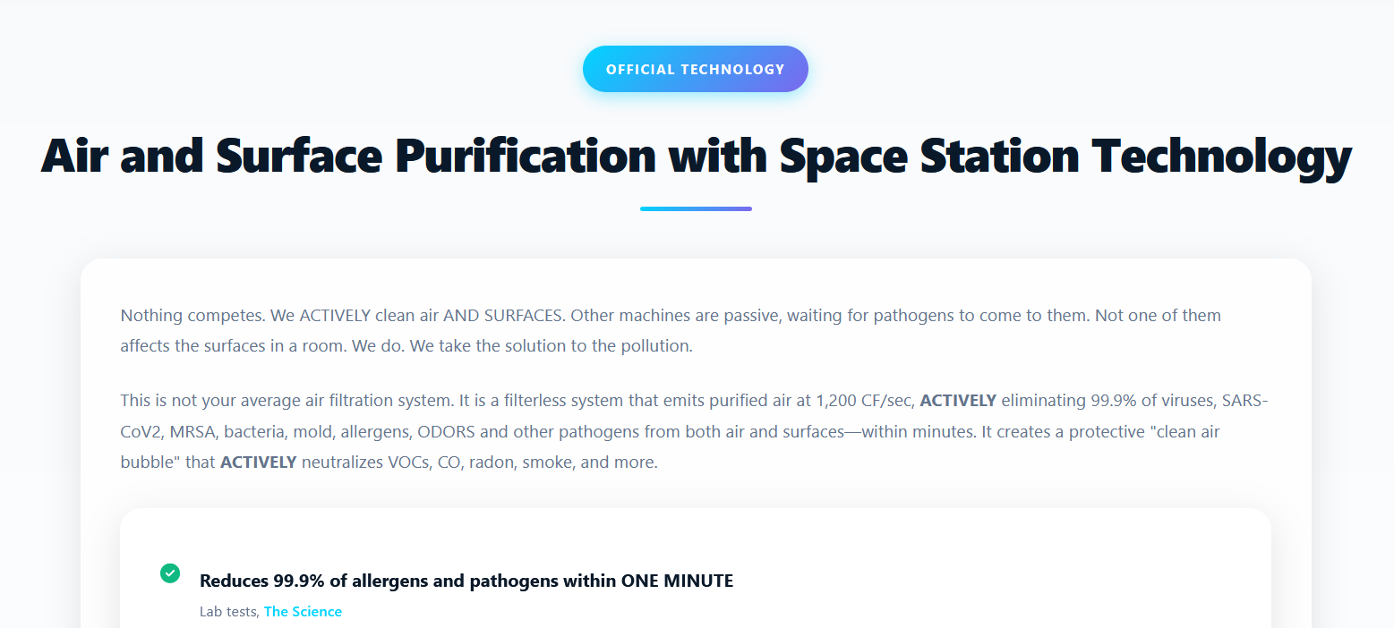
Add: Diluting the Pollution one machine at a time.
Enlarge Text

[Whole House Air video link, open in New Window?]

Change 99.97% to 99.9% - to cover both Company’s science – add, respectively, labels: Water – Air, Air, Water – Air, Water – Air to address specific testing of products. Neither water product is FDA tested. Only Air.)
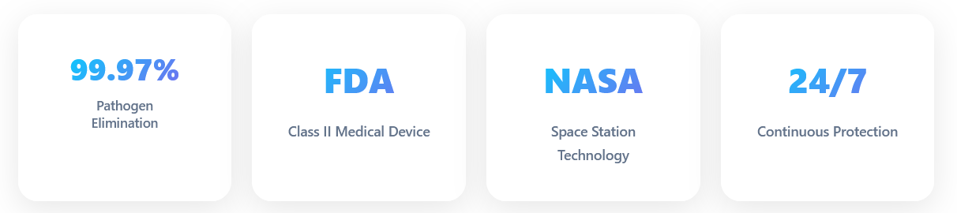
(Leave Air same – blurb on air above)
(Now continue updated Commercial…)

Change to ‘Commercial – Industrial - Municipal Solutions
New Construction - Business Licensees

Our CleanWater Systems are capable of allowing you to sip CleanWater from a running stream, sitting puddle or faucet with no worry what else is in your water. Toppen provides top notch water filtration and restructuring, best in the universe.
The LivingWater machine’s micro-clustered water allows you to dial your Ph. This gives you the power to explore a cleaner and chemical-free environment – poured from your tap. Your budget and fewer trips to the store, garbage and fridge will thank you.
(Whole House graphic - video)
INDUSTRIAL, MUNICIPAL,
NEW CONSTRUCTION and DATA CENTERS

RESIDENTIAL and
SMALL BUSINESS
Based on GPM

Click Here for a Residential CleanWater System
Hyperlink into product lines….

Click Here for Industrial -M-N-D-CleanWater System

Drop into Comm-Industrial – Municipal

Change ‘Our Products’ display to be(3) – (1) ‘Commercial – Industrial - Municipal Solutions‘ – (2) ‘Portable Plug-in Models‘ – (3)‘Personal Portable Units‘ Remove HVAC-Integrated Units

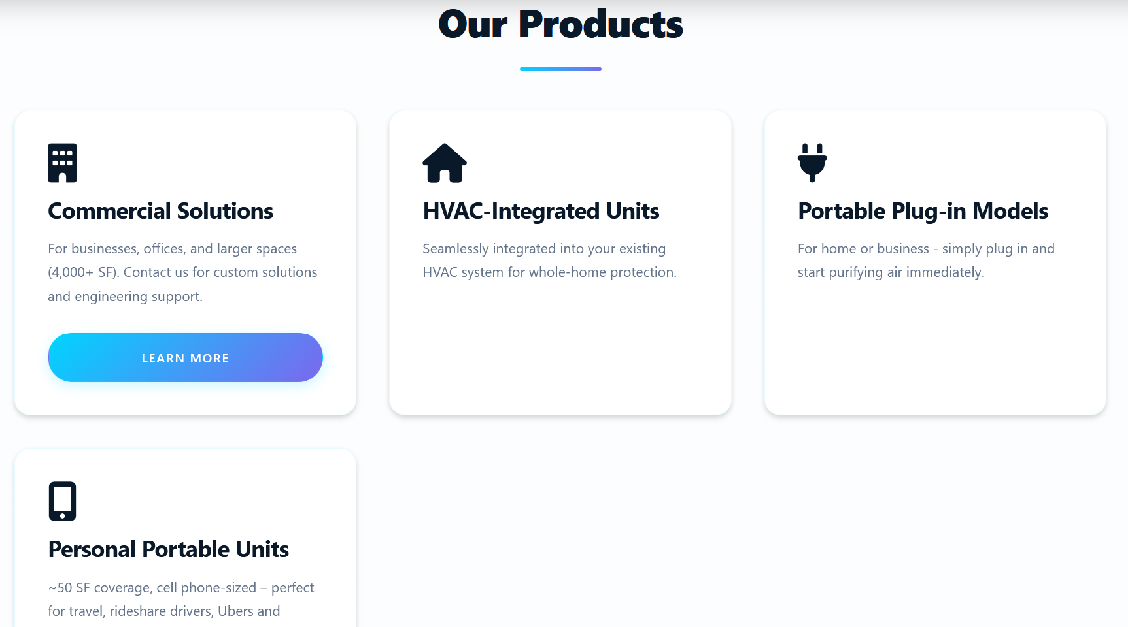

Change ‘Official Statement’ display to be – Water: We dilute the pollution with CleanWater.
Air: We bring the solution to the pollution.


Remove this from Home Page….
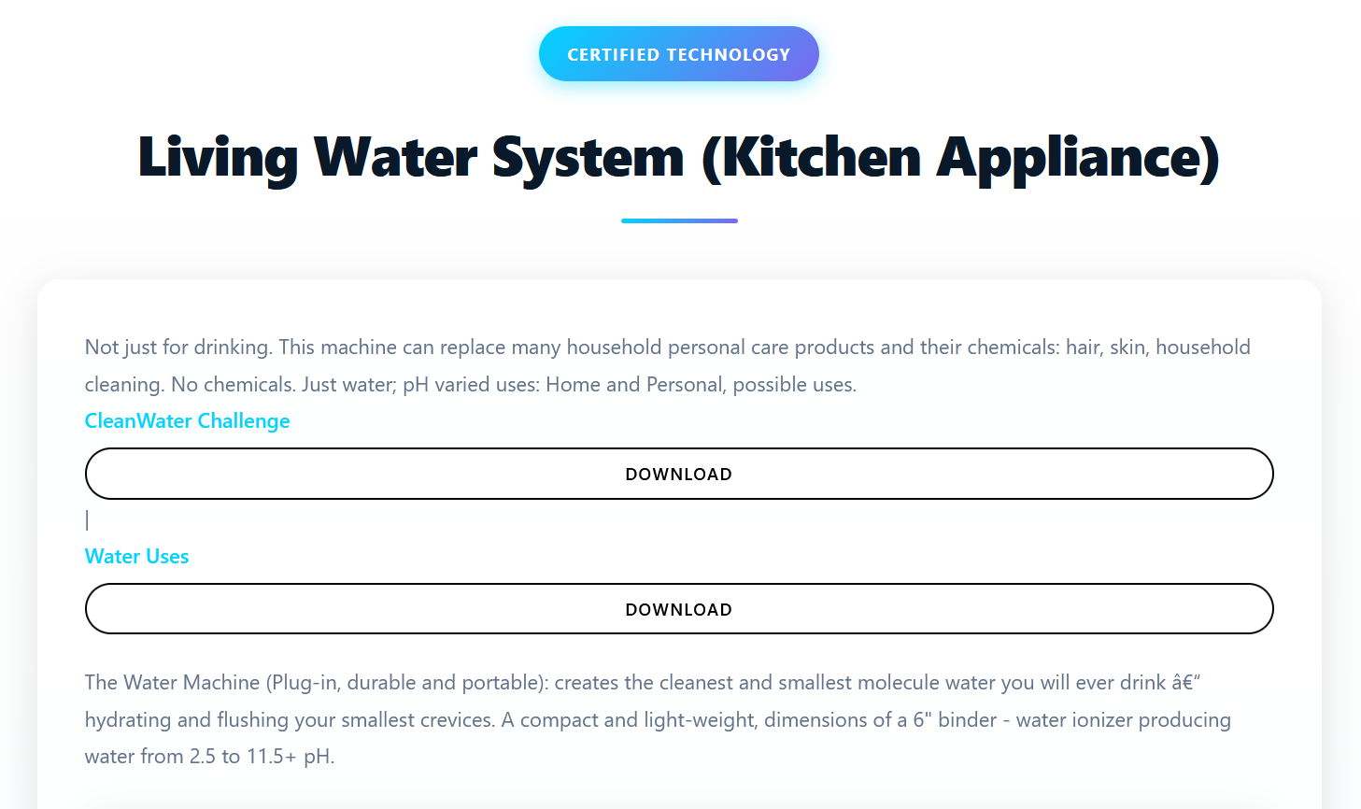
Remove ‘Living Water’ reference from Home Page and will be on the Vollara machine page, design page as
‘The Champagne of Water’ (wherever this phrase is used, hyperlink – open in new window - to Vollara LivingWater machine)…finishing and ‘Dialing your pH’.

…and add this….CleanWater’s Whole House System
[Graphic flow-chart video, starting Wh-Hse to LivingWater = initial entry to Champagne.]

After cleaning all pathogens, toxins, chemicals, spores, and more from your CleanWater, use the LivingWater machine to add more life into your Living. The LivingWater machine allows you to control your water pH, using water for more than just drinking. Feel what it’s like to be strapped into your body suit and FEEL GREAT.

Hyperlink, LivingWater, Vollara Machine/Science: The Champagne of Water. Chemistry 101,

Water:
2.5 pH sanitizes. It is like bleach with no chemicals.
4.0 – 5.5 pH is excellent for external skin for humans and pets.
7.0 pH – Pets, kids under 5 years old and when taking pharmaceuticals.
8.5 – 10.0 pH is GREAT for human consumption and ENERGY.
11.5 pH works as a degreaser.
LEARN
Water Uses
TAKE
The Water Challenge
Hyperlink, open PDF in new window for each… –

MicroClustered water immediately soaks into dirt, grime and CLEANS like new.
…Streakless glass cleaner (if you wipe in circles).
Leave LivingWater video below paragraph above & Whole House video.
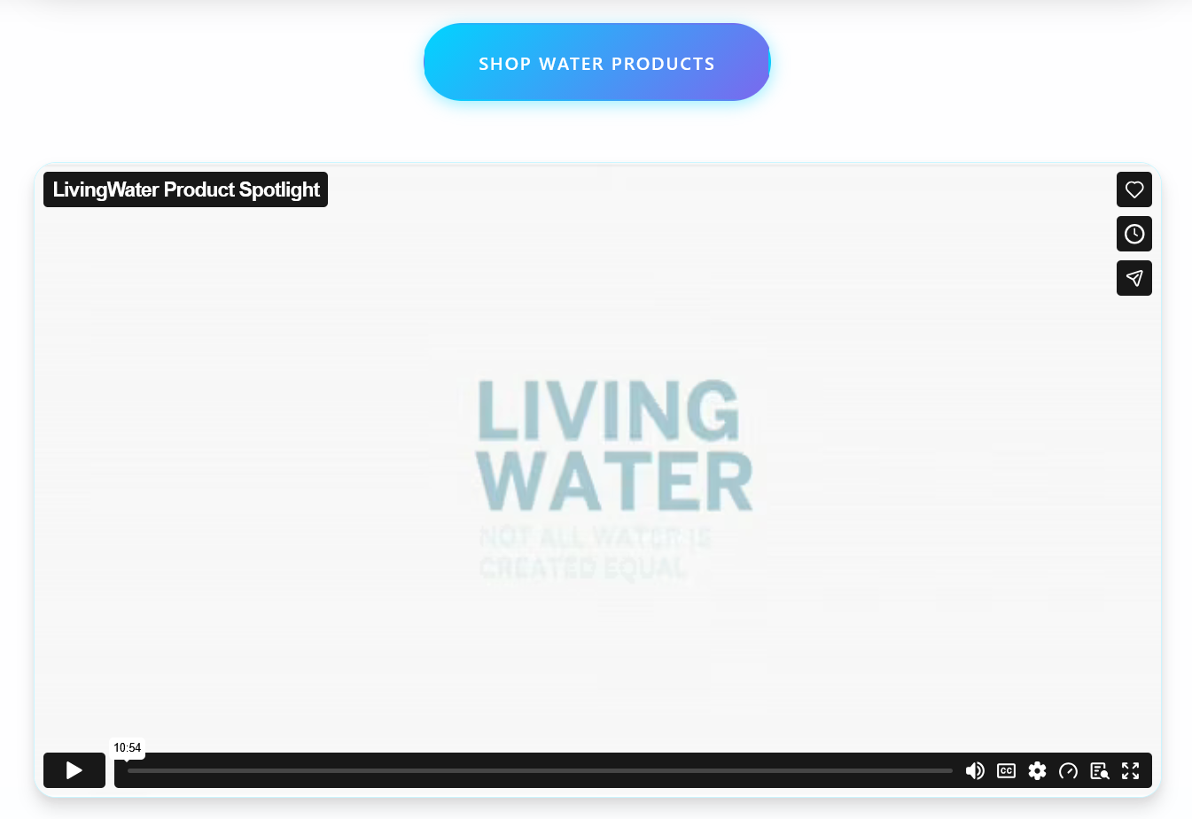

Leave LaundryPure

Leave Electricity
…Remove ‘Shop’ and leave the remaining 4 options….
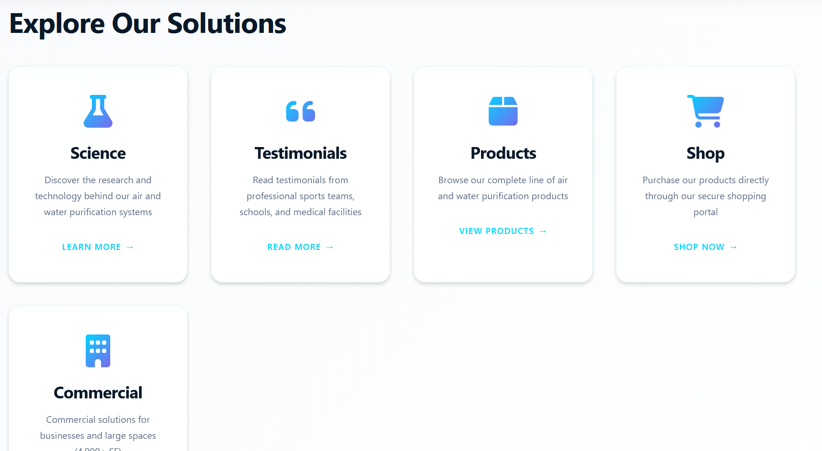
INDUSTRIAL, MUNICIPAL,
NEW CONSTRUCTION and DATA CENTERS

End of Home Page edits.

