Quality Water While on the Go or Emergency.
The Straw Kit is your clean water solution for replenishing yourself at any fresh water source. Healthy water for drinking anywhere, anytime. Our filtration system uses the same technology used by NASA. It filters water with no chemicals. Emergency Water Kit creates healthy and great tasting water for you to enjoy.

Purer Then Bottled Water

Saving the planet, replacing bottled water with our Filtration Systems.
- No Chemicals.
- 99.999999% Removal of Bacteria
- >99.99% Removal of Spores, Bacteria, Cysts
- Viruses, pathogens, mold, fungus
- Adding Micro-Nutrients & Minerals for Optimum Health benefits
- Eco-Friendly
- Eliminates the use for plastic water bottles

Never be without an option for Clean Water again. Our filtration allows you to draw Clean Water from any fresh-water source.
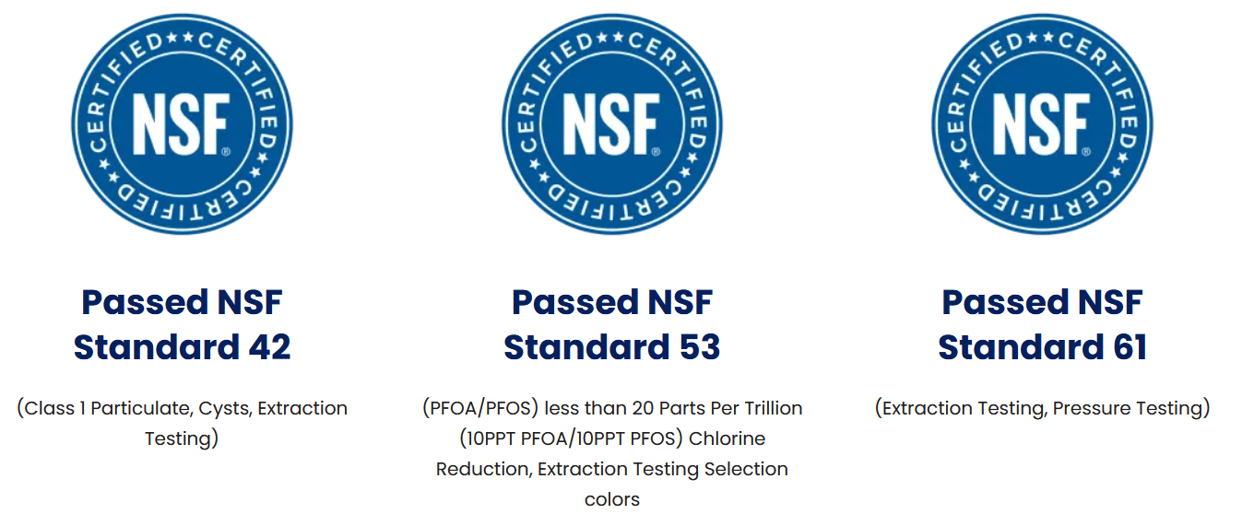

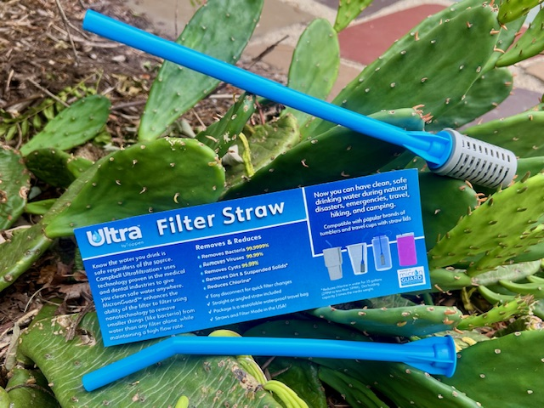

Unit Price: $29.99
Tax (Varies) $
Shipping (Varies) $
Total $
SKU 50302-01 Shop | 2 Straw Kit w/One Filter
Filtration System for up to 350 Gallons

Product Details

The Emergency Water Kit filters use a proprietary patented electro-positive filter media that rapidly adsorbs particles, as small as a few nanometers.
  - Advanced Ultra Filtration
  - NSF-42 certified
  - No Chemicals
  - Bacteria, Virus, Cysts, Particulate Removal
  - 200 Gallon capacity
  - Low cost to maintain
  - Easy to maintain
  - Great tasting water
  - Water on the go, without the weight.

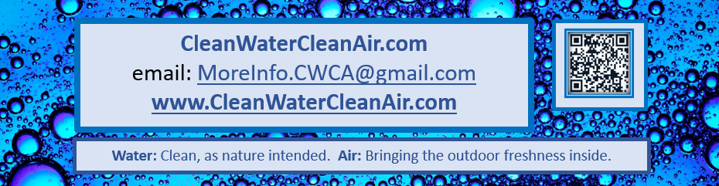
Never question what is in your water again.

