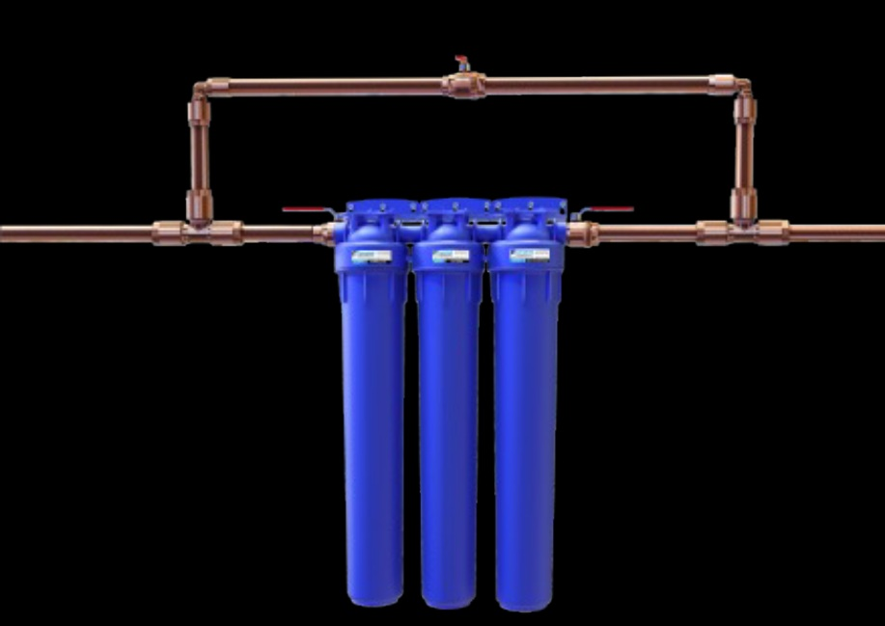
SKU T-50101-01 Shop | Ultra Home
UltraSafe SS System – Well Water
UltraSafe SS System™
Filtration System for Under 5 - 10 GPM

Quality Water For Your Whole House.
The Toppen UltraHome Filtration System is your clean water solution for you & your family. It creates healthy water for drinking, cleaning, and bathing. Our filtration system uses the same technology used by NASA. It filters water with no chemicals. The Toppen UltraHome Filtration System creates healthy and great tasting water for your family to enjoy.

Purer Then Bottle Water

Saving the planet, replacing bottled water with UltraHome Filtration System.
- No Chemicals.
- 99.999999% Removal of Bacteria
- >99.99% Removal of Spores, Bacteria, Cysts
- PFAS / PFOS / PFOA – Forever Chemicals
- Viruses, pathogens, mold, fungus
- ‘Allowable Toxins’ – chlorine
- Heavy Metals, Lead, Micro-Plastics
- Pesticides, Pharmaceuticals
- Adding Micro-Nutrients & Minerals for Optimum Health benefits
- Eco-Friendly
- Eliminates the use for plastic water bottles
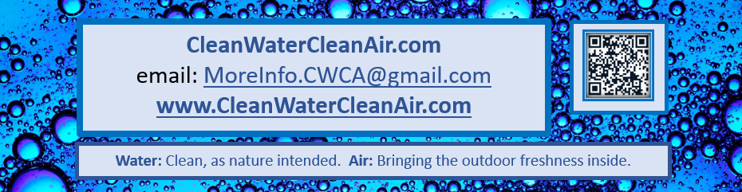

Product Details
The Toppen UltraSafe SS System filters use a proprietary patented electro-positive filter media that rapidly adsorbs particles, as small as a few nanometers.
  - Advanced Ultra Filtration
  - Great tasting water
  - NSF certified, 42, 53, 61, 372
  - No Chemicals
  - Large capacity filters
  - Annual change out in most applications
  - Water softening (Optional on request)
  - Low cost to maintain
  - Easy to maintain

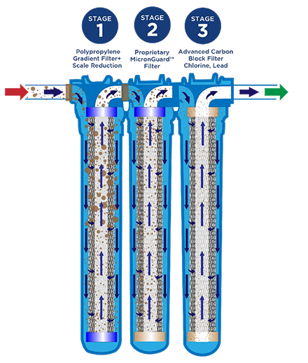
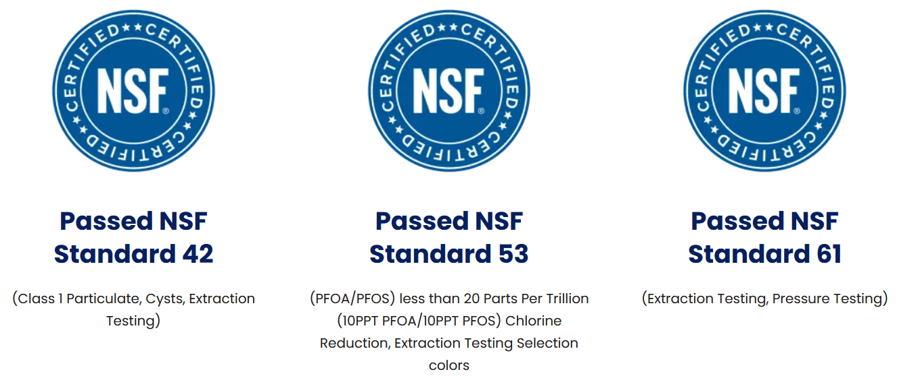

Never question what is in your water again.

Unit Price: $1,899.00
Tax (Varies) $
Shipping (Varies) $
Total $
Button - Proceed to Check-Out…CC Authorization, etc.
Input mailing address, cc info, billing, email.
Split Order to Toppen, Funds, Order, Order #, Subtotal, Transfer of funds including shipping, Toppen packages and ships, needs packing slip.
Never question what is in your water again.

